CONSENT ITEM G
April 28, 2025
OLDHAM COUNTY BOARD OF EDUCATION
CONCERN
Consider Shortened School Day requests for OCS students.
DISCUSSION
The following students have requested a Shortened School Day. Details for each student follow this enclosure for your review.
STUDENT | SCHOOL
S.H. | OCHS
I.W. | HA
RECOMMENDATION
Post-approve the shortened school day request for these students.

On a motion by _______________, seconded by _______________, the Board post approved the Shortened School Day requests as submitted. ( , )


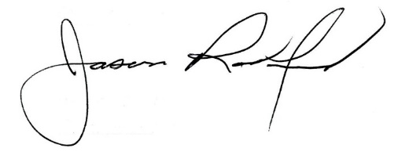

Carly Clem, Board Chair Jason Radford, Superintendent/Secretary

