CONSENT ITEM A
April 28, 2025
OLDHAM COUNTY BOARD OF EDUCATION
CONCERN
Consider Approval of Field Trips Requesting Overnight Stay & Field Trips Requesting Use of Common Carrier.
DISCUSSION
The following are field trips requesting overnight stay and trips requesting use of a common carrier:
SCHOOL | GROUP | LOCATION/DATE | JUSTIFICATION | INSTR. DAYS LOST
SOHS | FCCLA | Hardinsburg, KY  May 28-30, 2025 | Overnight: Training Camp  Board Vehicle | 2
NOHS | Field Hockey | St. Louis, MO  August 30-31, 2025 | Overnight: Gateway Classic  Charter Bus | 0
NOHS | Football | Gardner Webb University  June 6-9, 2025 | Overnight: Camp  Car Rental | 0
Arvin | HOSA | Frankfort, KY  April 25-27, 2025 | Overnight: HOSA Training  Parents | 0
OCHS | Cross Country | Cary, NC  October 3-5, 2025 | Overnight: Tournament  Charter | 1
Arvin | HOSA | Locations TBD  Dates TBD | Overnight: Tournament  Board Vehicle | 0
SOHS | Speech/Debate | Des Moines, IOWA  June 15-21, 2025 | Overnight: Tournament  Parent | 0
NOHS | Cross Country | Huntsville, AL  October 3-4, 2025 | Overnight: Tournament  Parent | 0
NOHS | Cross Country | Cary, NC  Sept 19-21, 2025 | Overnight: Tournament  Charter | 1
NOHS | Cross Country | Oxford, OH  July 24-26, 2025 | Overnight: Camp  Bus | 0
Approve the field trips as attached and described above, pursuant to the condition that students not traveling on school buses, with their parents, or with a Board employee whose insurance carrier has named OCBE as an additional named insured, will be transported to and from their destination on an approved charter bus(es) and school(s) shall obtain written evidence of liability.

Motion Passed: Motion by _______________, seconded by _______________, the Board gave approval of the field trips as attached and described above, pursuant to the condition that students not traveling on school buses, with their parents, or with a Board employee whose insurance carrier has named OCBE as an additional named insured, will be transported to and from their destination on an approved charter bus(es) and school(s) shall obtain written evidence of liability. ( , )
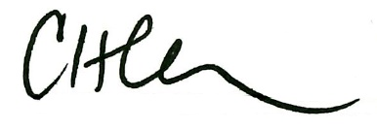
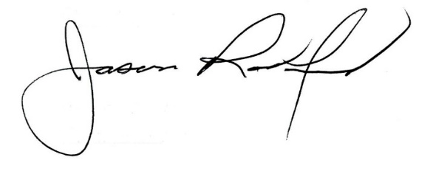

Carly Clem, Board Chair Jason Radford, Superintendent/Secretary

