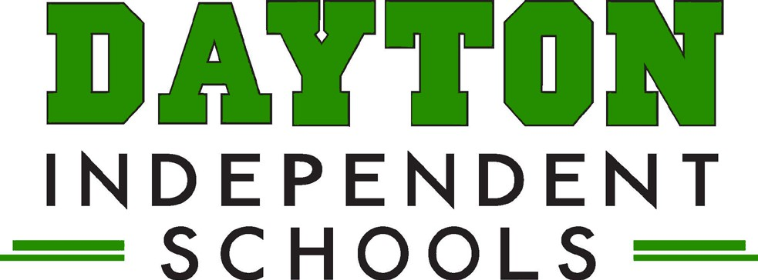

Grants Report
April 23, 2025
Grants in Progress:

- McKinney Vento Grant -
- Positive Action Grant
- Northern Kentucky Institute for Arts Integration
- Trauma Informed School Services
- School Based Mental Health Grant
- Prichard Community Schools Grant
- 21st Century Community Learning Grant – LES and DHS. LES is operating under the last year of the current grant cycle and will be applying for the grant again with the YMCA as their partner
- 21st Century Expansion grant – LES (NEW)
- KYOAAC – Opioid Abatement Commission – Funding Received – Use for Steered Straight Event

Grants Submitted and Pending:

- GEAR UP grant – Award notification by September 2025
- Connecting Kids to Coverage – this grant provides funds to enroll and retain eligible children in Medicaid and CHIP – Submitted March 7
- Strategic Prevention Grant – submitted March 18

Grants Available:

