THIS IS A DECISION PAPER
TO: HARDIN COUNTY BOARD OF EDUCATION
FROM: TERESA MORGAN, SUPERINTENDENT
DATE: April 17, 2025
SUBJECT: APPROVAL OF TWO DISTRICT-WIDE CUSTODIAL SUBS
FACTS:
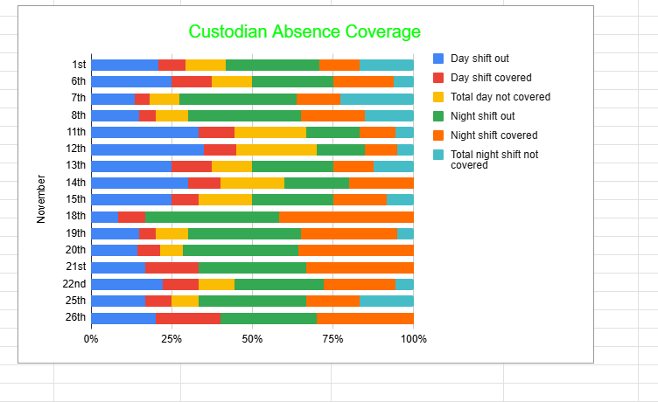
RECOMMENDATION
I RECOMMEND THE BOARD APPROVE TWO ADDITIONAL DISTRICT-WIDE CUSTODIAL SUB POSITIONS TO START THE 25-26 SCHOOL YEAR.
RECOMMENDED MOTION
I MOVE THE HARDIN COUNTY BOARD OF EDUCATION APPROVE TWO ADDITIONAL DISTRICT-WIDE CUSTODIAL SUB POSITIONS TO START THE 25-26 SCHOOL YEAR.

