FY 2026: Declaration of Participation Report

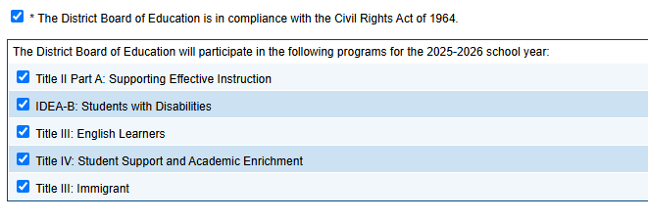

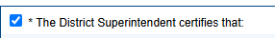

1. | The District will participate for SY 2025-2026 in the identified federal programs as indicated in District Board of Education section of this application.
  X Yes
  No
2. | All private non-profit schools and home schools physically located in the public district's geographic boundaries have been notified by certified mail or other signed documentation of the purposes and benefits of, and given equitable opportunity to participate in, the federal Title II Part A, Title III EL/Immigrant, Title IV and IDEA-B programs.
3. | Signed Private Nonprofit Schools and Home Schools Declaration of Participation forms are on file in the local board of education office documenting the stated numbers of participating private, non-profit school and home school students.
4. | Any private school participating in the federal programs has filed with the district a signed assurance statement verifying an official non-profit status. Home schools, by their nature, are considered non-profit.

