CONSENT ITEM A
March 24, 2025
OLDHAM COUNTY BOARD OF EDUCATION
CONCERN
Consider Approval of Field Trips Requesting Overnight Stay & Field Trips Requesting Use of Common Carrier.
DISCUSSION
The following are field trips requesting overnight stay and trips requesting use of a common carrier:
SCHOOL | GROUP | LOCATION/DATE | JUSTIFICATION | INSTR. DAYS LOST
SOHS | Softball | UK | Overnight: Tournament  Bus or Parents | 0
SOHS | Tennis | Top Seed Tennis | Overnight: Tournament  Parents | 0
SOHS | Baseball | UK | Overnight: Tournament  Parents | 0
SOHS | Tennis | Top Seed Tennis | Overnight: Tournament  Parents | 0
OCHS | Softball | UK  June 5-7, 2025 | Overnight: Tournament  Parents | 0
OCHS | Boys VB | May, 2025 | Overnight: Tournament  Bus | 0
OCHS | Girls LaCrosse | May 2025 | Overnight: Tournament  Bus | 0
OCHS | Softball | Bowling Green  May 2025 | Overnight: Tournament  Bus | 0
OCHS | Boys VB | George Rogers Clark  May 2025 | Overnight: Tournament  Bus | 0
OCHS | Tennis | UK  June 2025 | Overnight: Tournament  Parents | 0
OCHS | Baseball | UK  June 2025 | Overnight: Tournament  Bus | 0
OCHS | Baseball | UK  May 2025 | Overnight: Tournament  Bus | 0
SOHS | FCCLA | Galt House  April 23-25, 2025 | Overnight: State Competition  Bus | 3
OCHS | Bass Fishing | Lake Cumberland  April 24-26, 2025 | Overnight: Tournament  Parents | 1
SOHS | Speech/Debate | Des Moines, Iowa  June 15-20, 2025 | Overnight: Tournament  Parent | 0
SOMS | ATLAS Club | Washington, DC  April 23-25, 2026 | Overnight: 8th Grade Trip  Tour Company | 2
ARVIN | FBLA | Galt House, Louisville  April 14-15, 2025 | Overnight: State Conference  District Vehicle | 0
OCHS | Bass Fishing | Lake Cumberland  May 8-10, 2025 | Overnight: State Championship  Parents | 2
NOMS | Gates | New York  May 6-8, 2025 | Overnight: Hamilton EDU Competition  Air | 3
SOHS | Boys &Girls Bball | Rupp Arena  March 25&27, 2025 | Overnight: State Tournament  Bus | 2
Approve the field trips as attached and described above, pursuant to the condition that students not traveling on school buses, with their parents, or with a Board employee whose insurance carrier has named OCBE as an additional named insured, will be transported to and from their destination on an approved charter bus(es) and school(s) shall obtain written evidence of liability.

Motion Passed: Motion by _______________, seconded by _______________, the Board gave approval of the field trips as attached and described above, pursuant to the condition that students not traveling on school buses, with their parents, or with a Board employee whose insurance carrier has named OCBE as an additional named insured, will be transported to and from their destination on an approved charter bus(es) and school(s) shall obtain written evidence of liability. ( , )

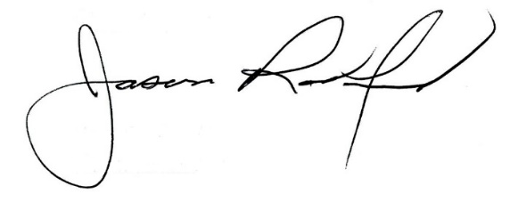

Carly Clem, Board Chair Jason Radford, Superintendent/Secretary

