CONSENT ITEM F
MARCH 24, 2025
OLDHAM COUNTY BOARD OF EDUCATION
CONCERN
Consider Approval of Requests for Various Certifications from the Education Professionals Standards Board for FY26.
DISCUSSION
Below list various certifications requiring approval from the Board of Education to make requests from the Education Professionals Standards Board:
- One-Year Approval for School Media Librarians
A request for a one-year approval (FY26) from Education Professionals Standards Board is sometimes necessary for Elementary Library/Media Specialists. In these instances, the Library/Media Specialists are elementary certified teachers enrolled in a program toward LMS certification and have all completed more than nine (9) of the required college hours for probationary status.
- Emergency Certification Applications
It is sometimes necessary to request Emergency Certification from Education Professional Standards Board for teachers for a variety of reasons. In these instances, we have made diligent efforts to advertise for and recruit/hire a qualified teacher and have found that the applicant eligible for emergency certification is the best candidate for the position.
- Adjunct Instructor
It is sometimes necessary to request Adjunct Certification from Education Professional Standards Board for teachers for a variety of reasons. These people will be employed for part-time services only.
- Substitute Teachers
It is necessary to request 250 Emergency Substitute Teacher certifications from Education Professional Standards Board. These people will be renewed each year.
RECOMMENDATION
Approve submission of these applications to the Education Professional Standards Board Division of Certification for FY26.

On a motion by _______________ , seconded by _______________, the Board approved the submission of the above applications to the Education Professional Standards Board Division of Certification for FY26 as presented. ( - )

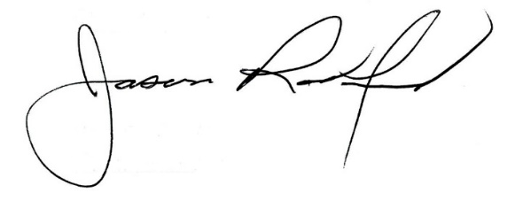
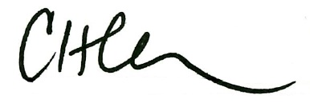

Carly Clem, Board Chair Jason Radford, Superintendent/Secretary

