TREASURER REPORT
March 24, 2025
OLDHAM COUNTY BOARD OF EDUCATION
CONCERN
Consider approval of the Treasurer Report
DISCUSSION
Report Number 1 provides a comprehensive overview of our cash accounts across all funds. As we enter our eighth month of reporting for February, we have recorded total receipts and disbursements leaving a total for all funds exceeding $75 million. Additionally, this report includes a detailed breakdown of our bonded construction funds and investment account.
Report Number 2 offers further insights, presenting a more detailed analysis of cash totals for all funds.
Report Number 3 is the historical actual comparison report, which contrasts the current year's performance with previous years regarding both revenue and expenses. This report indicates that we are performing quite well in our financial tracking.
Included in your packet are the historical actuals report, along with the standard balance sheet and income statement for your review.
RECOMMENDATION
Approval of the Treasurer Report

On a motion by _______________, seconded by _______________, the Board approved the Treasurer Report. ( , )

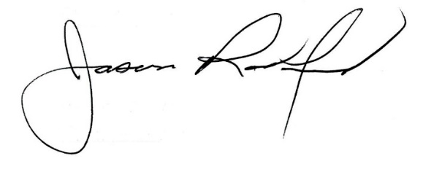
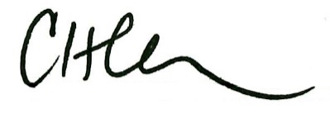

Carly Clem, Board Chair Jason Radford, Superintendent/Secretary

