ACTION ITEM D
March 24, 2025
OLDHAM COUNTY BOARD OF EDUCATION
CONCERN
Over the past few years, the Board of Education has taken action to raise salaries for all employees. As this was needed action in the recruitment and retention of staff, it has resulted in additional costs for our afterschool enrichment programs. In addition, ESSER grants were granted to our afterschool enrichment programs which helped ease the additional costs of staffing in recent years. All of those monies have now been spent.
DISCUSSION
Our current summer rates are at a much lower rate than any program in the area. We would like to consider raising the rate an additional $20 for every student during the summer of 2025 and an additional $5 during the school year. These rates will be effective on June 1, 2025.
Current Full Time- Summer (10 weeks)
 |  | Current Tuition | Proposed Increase
1st Child/ each week |  | $140 | $160
Additional Child/ each week |  | $100 | $120
Full Time Board Employees-Summer
 | Current Tuition |  | Proposed Increase
1st Child | $80 |  | $100
Additional Child | $70 |  | $90
School Year Full Time Contracts (36 weeks/170 Instructional Days)
 | Current Tuition |  |  | Proposed Increase
1st Child/ each week | $85 |  |  | $90
Additional Child/ each week | $60 |  |  | $65
School year Full Time Board Employees (36 weeks/172 Instructional Days)
 |  | Current Tuition |  |  | Proposed Increase
1st Child |  | $65 |  |  | $70
Additional Child |  | $50 |  |  | $55
RECOMMENDATION:
Approve the new rates for Enrichment Centers effective June 1, 2025.

On a motion by _______________, seconded by _______________, the Board approved the new rates for Enrichment Centers effective June 1, 2025 as presented. ( , )
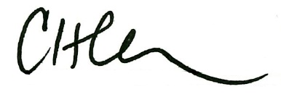
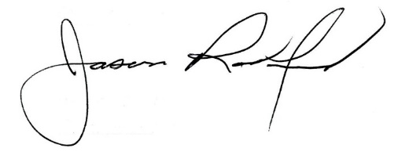

Carly Clem, Board Chair Jason Radford, Superintendent/Secretary

