ACTION ITEM C-16
March 24,2025
OLDHAM COUNTY BOARD OF EDUCATION
CONCERN
Increase in student numbers for the Gateway 4/5 program.
DISCUSSION
Student enrollment for all 4 and 5th graders who were identified for participation in the Gateway Academy will significantly increase for the 2025-26 school year. Due to the increased numbers the district will need to staff the Gateway Program with two full-time teachers. This is up from 1.3 staff members this year.
RECOMMENDATION
Approve the recommendation of increasing Gateway staffing for the 2025-26 school year, to 2.0 full-time staff members, up from 1.3 staff members.

On a motion by _______________, seconded by _______________, the Board approved the recommendation of increasing Gateway staffing for the 2025-26 school year, to 2.0 full-time staff members up from 1.3 staff members. ( , )


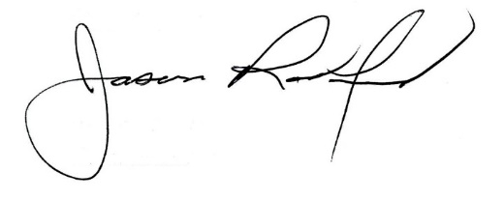

Carly Clem, Board Chair Jason Radford, Superintendent/Secretary

