ACTION ITEM C-15
March 24, 2025
OLDHAM COUNTY BOARD OF EDUCATION
CONCERN
Employee engagement and retention of our classified bus monitor staff.
DISCUSSION
During the roadshow we were informed of an issue with bus monitors and pay. Upon review bus monitors work a typical 6-hour day, but since their contract is only for 4 hours a day, they each lost the equivalent of about 20 hours of pay over the 10 NTI days. With the days being so close together, it has placed significant strain on them during this time.
We are proposing to increase their hourly contract from 4 hours a day to 6 hours a day. They are each currently working 6 hours a day. This means there will not be an increase in costs except for an NTI day. However, if we were in school, they would have received 6 hours of pay.
RECOMMENDATION
Approve the recommendation to increase bus monitor hourly contract to 6 hours a day.

On a motion by _______________, seconded by _______________, the Board approved the recommendation to increase bus monitor hourly contract to 6 hours a day. ( , )


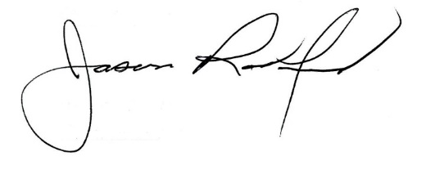

Carly Clem, Board Chair Jason Radford, Superintendent/Secretary

