ACTION ITEM C-14
March 24, 2025
OLDHAM COUNTY BOARD OF EDUCATION
CONCERN
Employee engagement and retention of our classified nursing staff.
DISCUSSION
Each year we review a quarter of all job descriptions district wide. Out of 47 job descriptions reviewed, the nursing job description is one that needs to be updated. After a review by Ms. Burgess, the district nurse. It was very evident that our compensation for our school nurses was well below market value. We took the information proved to the budget work group and after reviewing with the entire group, the budget work group proposes the following change.
- Nurses will move from a standalone salary schedule to the unified MAG salary schedule at 119, for 7 hours and 187 days.
RECOMMENDATION
Approve the recommended change of school nurses move to the 119 MAG salary schedule at 7 hours a day for 187 days.

On a motion by _______________, seconded by _______________, the Board approved the recommended change of school nurses move to the 119 MAG salary schedule at 7 hours a day for 187 days. ( , )


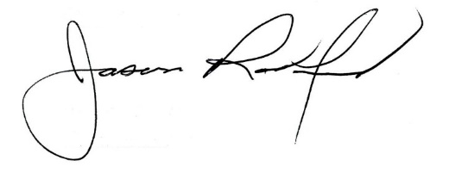

Carly Clem, Board Chair Jason Radford, Superintendent/Secretary

