ACTION ITEM C-13
March 24, 2025
OLDHAM COUNTY BOARD OF EDUCATION
CONCERN
Increase in duties and responsibilities of the Assistant to Benefits Coordinator.
DISCUSSION
See attached update to the AR and approve the proposed salary change from 108 to 110. We will also not be filling the current position because of this increase in duties, which will ultimately save money.
RECOMMENDATION
Approve the increase from 108 to 110 for the Assistant to Benefits Coordinator.

On a motion by _______________, seconded by _______________, the Board approved increase from 108 to 110 for the Assistant to Benefits Coordinator. ( , )


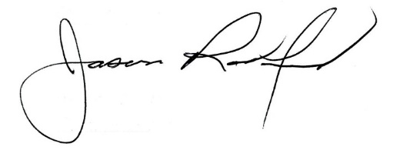

Carly Clem, Board Chair Jason Radford, Superintendent/Secretary

