ACTION ITEM C-12
March 24, 2025
OLDHAM COUNTY BOARD OF EDUCATION
CONCERN
Employee engagement and retention of certified and classified staff of our Exceptional Children Services department.
DISCUSSION
Over the course of multiple years, we have witnessed a decrease in staff retention in three specific classroom settings. This decrease in staffing coupled with a decrease in the applicant pool for these positions, plus an increase in the need to hire outside contract workers has led us to think differently about staffing these three classroom settings.
The three specific classroom settings are as follows:
- Functional Academic (FA) classroom.
- Communication and Behavior (CAB) classroom.
- Positive Behavior Support (PBS) classroom.
In an effort to retain and recruit qualified staff, both certified and classified, and reduce spending on contract workers, we are proposing a set stipend amount for each employee assigned in those classrooms.
Stipend amounts to be paid equally over the 24 pay periods.
- Certified staff $7,000 per assigned employee.
- Classified staff $3,500 per assigned employee.
RECOMMENDATION
Approve the recommended certified stipend of $7,000 and classified stipend of $3,500 for all (FA), (PBS), and (CAB) assigned staff for the 2025-2026 school year and beyond until further notice.

On a motion by _______________, seconded by _______________, the Board approved the recommended certified stipend of $7,000 and classified stipend of $3,500 for all (FA), (PBS), and (CAB) assigned staff for the 2025-2026 school year and beyond until further notice. ( , )

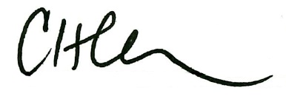
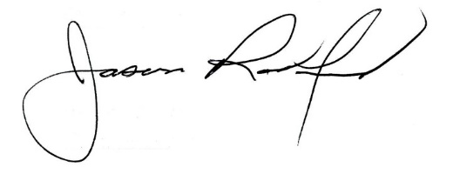

Carly Clem, Board Chair Jason Radford, Superintendent/Secretary

