ACTION ITEM C-11
March 24, 2025
OLDHAM COUNTY BOARD OF EDUCATION
CONCERN
Continued effort to recruit and retain employees.
DISCUSSION
In 2021, the board approved a new salary schedule to compensate club sponsors and extracurricular stipends. This was done to establish a responsible budgeting approach, taking into account our projected annual costs. We moved away from a percentage base compensation package to a fixed compensation amount. Since that change the club and extracurricular stipend have not increased in relation to any other pay raises the past 5 years.
The budget work group, along with others, are proposing a $250 increase to all clubs and extracurricular stipends on the approved club and extra-curricular stipend sheet. Staff who are still grandfathered in the old system will stay at the same rate unless the new rate is higher.
RECOMMENDATION
Approve the $250 increase for all club and extra-curricular stipends for the 2025-2026 school year.

On a motion by _______________, seconded by _______________, the Board approved the $250 increase for all club and extra-curricular stipends for the 2025-2026 school year. ( , )

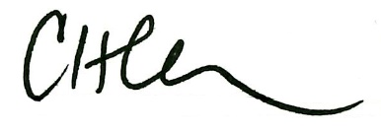
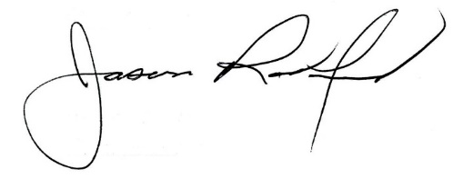

Carly Clem, Board Chair Jason Radford, Superintendent/Secretary

