ACTION ITEM C-10
March 24, 2025
OLDHAM COUNTY BOARD OF EDUCATION
CONCERN
Continued efforts to elevate the family and community experience.
DISCUSSION
Due to responsible budgeting efforts over the past year, the budget committee agrees with the Board of Education to provide some financial relief to parents this upcoming year in terms of school fees. This may become a yearly decision based on the available carry-forward money at the end of each financial year.
This year the budget committee is proposing a $40 reduction in yearly school fees per student. For the 2025-2026 school year we are suggesting lowering:
- The basic student fee from $30 to $10
- The basic student technology fee from $30 to $10
The board will also fund each school as if each student paid the total amount of $60. Meaning the board will transfer $40 per student to the school after enrollment numbers are set and agreed upon. This will cost the district an estimated $415,000.
RECOMMENDATION
Approve the recommended reduction of $40 to basic student fees for the 2025-2026 school year only to provide some financial relief to parents and families. While continuing to fund each school with the difference from one-time carry-forward funds.

On a motion by _______________, seconded by _______________, the Board approved the recommended reduction of $40 to basic student fees for the 2025-2026 school year only to provide some financial relief to parents and families. While continuing to fund each school with the difference from one-time carry-forward funds. ( , )

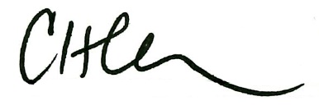
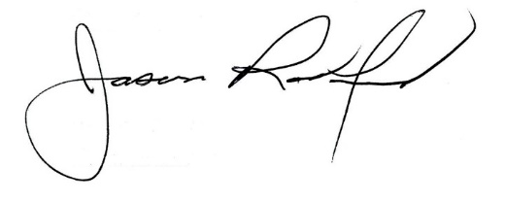

Carly Clem, Board Chair Jason Radford, Superintendent/Secretary

