ACTION ITEM C-9
March 24, 2025
OLDHAM COUNTY BOARD OF EDUCATION
CONCERN
Continued need to expose middle school students to multiple career and educational opportunities in both high school and post-secondary studies.
DISCUSSION
Oldham County Schools wants to continue to provide resources and opportunities for all students to explore their passions and then develop the necessary skills and background to accomplish their goals. To build on this promise of a student’s passion to a pathway, we would like to introduce a new resource and opportunity to all middle school students with the creation of a new middle school passion to pathway course. To complete this project each middle school will need one additional staff member above their allocation for the 2025-2026 school year and new instructional material to implement.
We are asking for 4 new staff members at each of the four middle schools and the new instructional materials to go with it. The staff increase will cost approximately $270,000, moving forward from general funds. The instructional resources will be funded by one-time money that was saved based off sound budgeting the past couple of years. This will cost approximately $450,000, which will include furniture, instructional kits, tools and resources needed to provide the instruction.
RECOMMENDATION
Approve the funding for one additional teacher at each of the middle schools and the instructional resources needed to provide this learning opportunity.

On a motion by _______________, seconded by _______________, the Board approved the funding for one additional teacher at each of the middle schools and the instructional resources needed to provide this learning opportunity. ( , )

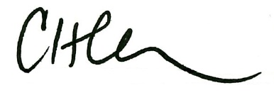
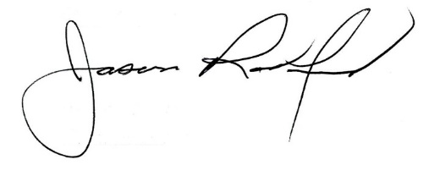

Carly Clem, Board Chair Jason Radford, Superintendent/Secretary

