ACTION ITEM C-8
March 24, 2025
OLDHAM COUNTY BOARD OF EDUCATION
CONCERN
Ensuring all students have access to the resources they need by removing barriers to learning.
DISCUSSION
For the past several years Oldham County Schools have seen a decrease in Title I funding, however, the need to reduce learning barriers and provide resources for students is still present. Multiple workgroups and schools have requested help to reduce learning barriers and provide a multitude of resources to meet students’ educational needs.
Due to responsible budgeting and management of money, we are asking that one time carry forward money be used in this upcoming school year to help provide resources that reduce barriers to learning. The resources provided will be decided upon by each school which might include but are not limited to intervention, instructional resources, extra time stipends and more. The amount of money will be based off the enrolled number of students identified for free and reduced status. We are proposing that $100 per student, per school, be provided for each student who qualifies. This program is estimated to cost approximately $270,000.
RECOMMENDATION
Approve the funding request of $100 per student, per school, for the purpose of reducing learning barriers for students.

On a motion by _______________, seconded by _______________, the Board approved the funding request of $100 per student, per school, for the purpose of reducing learning barriers for students. ( , )


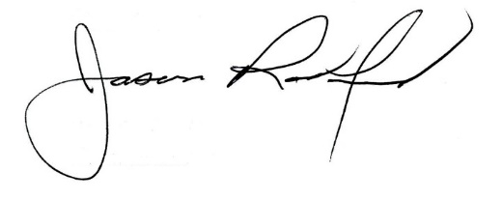

Carly Clem, Board Chair Jason Radford, Superintendent/Secretary

