ACTION ITEM C-7
March 24, 2025
OLDHAM COUNTY BOARD OF EDUCATION
CONCERN
Continue to provide students with an educational experience that meets the fast pass world of technology.
DISCUSSION
Schools continue to struggle with finding ways to keep up with the ever-changing world of technology. We want students to have reliable access to technology when warranted as well as know how to complete tasks without technology. In order to prepare our students for what is happening around them, we must provide resources and opportunities in the area of up-to-date technology. Just when schools and the district believe they are staying on top of the demand, it changes and or the technology starts to fail.
Our solution to this problem is to try and use our resources as wisely as we can, so we are suggesting using restricted funds which can’t be used for salary or other benefits but can be used for fixed assets and technology. The budget work group and others believe this is a good use of restricted funds.
We are asking for each K-12 school to receive $100 of restricted funds per student enrolled for the purpose of student technology needs first, then staff needs second. We are working out a ratio-based off enrollment for the Pre-school, Arvin and CAPPA, knowing they have sessions of students at different times and not all students enrolled attend at the same time.
RECOMMENDATION
Approve the $100 of restricted funds for the purpose of technology for all K-12 schools and a ratio based on final enrollment for the Pre-school, Arvin and CAPPA.

On a motion by _______________, seconded by _______________, the Board approved the $100 of restricted funds for the purpose of technology for all K-12 schools and a ratio based on final enrollment for the Pre-school, Arvin and CAPPA. ( , )


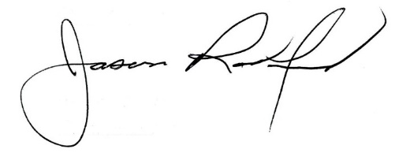

Carly Clem, Board Chair Jason Radford, Superintendent/Secretary

