ACTION ITEM C-6
March 24,2025
OLDHAM COUNTY BOARD OF EDUCATION
CONCERN
Employee engagement and retention of certified staff.
DISCUSSION
As we continue to increase our efforts in providing our employees with the best experience possible and compensate them for their contributions to the learning environment and culture of our school district, Oldham County is fortunate to have the dedicated certified staff that we currently have. We are also dedicated to recruiting the best new teachers every year.
The budget workgroup, along with the retention and recruitment workgroup, are proposing a plan to adjust the teacher salary schedule and all salary schedules tied to the teacher salary schedule by four years. This change would take effect starting July 1, 2025.
  - Adjust the teacher certified salary schedule by four years at the top. Meaning that the current 2024-25 0-3 years of experience on the matrix would be removed and starting the 2025-26 the teacher certified salary schedule year zero would match the 5% for year 4, if the 5% raise is approved.
  - All remaining rows will be filled in accordingly down the salary schedule to 33 years. This example was shown at all road shows and board work sessions.
RECOMMENDATION
Approve the creation of a new teacher salary schedule to include all salary schedules that work off the teacher salary schedule with the philosophy of the 4-year experience bump and working down the matrix.

On a motion by _______________, seconded by _______________, the Board approved the creation of a new teacher salary schedule to include all salary schedules that work off the teacher salary schedule with the philosophy of the 4-year experience bump and working down the matrix. ( , )

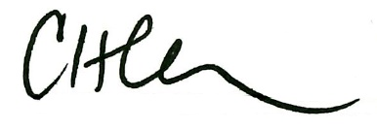
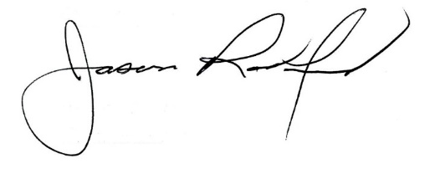

Carly Clem, Board Chair Jason Radford, Superintendent/Secretary

