ACTION ITEM C-5
March 24, 2025
OLDHAM COUNTY BOARD OF EDUCATION
CONCERN
Employee engagement and retention of both classified and certified staff.
DISCUSSION
As we continue to increase our efforts to provide our employees with the best experience possible and compensate them for their contributions to the learning environment and culture of our school district, Oldham County is fortunate to have dedicated classified and certified staff members with 27 or more years of service. With effort to retain veteran staff, the budget workgroup, along with the retention and recruitment workgroup, are proposing an extension of all salary schedules to 33 years starting July 1, 2025.
RECOMMENDATION
Approve the extension of all classified and certified salary schedules to 33 years.

On a motion by _______________, seconded by _______________, the Board approved the extension of all classified and certified salary schedules to 33 years. ( , )


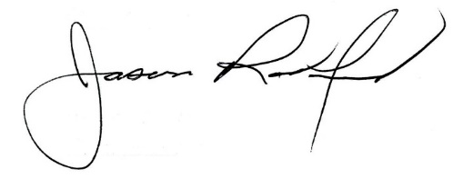

Carly Clem, Board Chair Jason Radford, Superintendent/Secretary

