ACTION ITEM C-4
March 24, 2025
OLDHAM COUNTY BOARD OF EDUCATION
CONCERN
Employee engagement and retention of certified staff.
DISCUSSION
As we continue to increase our efforts in providing our employees with the best experience possible and compensate them for their contributions to the learning environment and culture of our school district, Oldham County is fortunate to have the dedicated certified staff that we currently have. We are also committed to recruiting the best new teachers each year.
The budget work group, along with the retention and recruitment work group, are proposing an increase of compensation for our certified employees to start July 1, 2025.
- All certified staff will receive an increase for the 2025-2026 school year.
  - Certified staff will receive a minimum 5% raise.
RECOMMENDATION:
Approve the certified salary increase of 5% minimum for all certified staff.

On a motion by _______________, seconded by _______________, the Board approved the certified salary increase of 5% minimum for all certified staff. ( , )

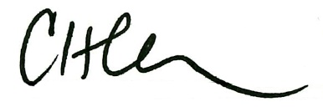
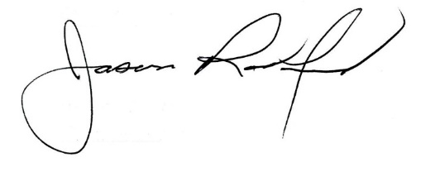

Carly Clem, Board Chair Jason Radford, Superintendent/Secretary

