ACTION ITEM C-2
March 24, 2025
OLDHAM COUNTY BOARD OF EDUCATION
CONCERN
Finalize the 2025 – 2026 Staffing Ratios for all traditional K-12 schools.
DISCUSSION
In early winter, a draft of student staff ratio numbers was presented at the budget and staffing meetings to the school leadership. Staffing ratios were also presented at all the Roadshows. Based on the recommendation from the budget committee and feedback during the last three months, we would present these ratios moving forward for the 2025-2026 school year.
K-5 / (23.20 :1)
6-8 / (23.65:1)
9-12 / (23.90:1)
RECOMMENDATION
Approve the recommendation to keep staffing ratios the same for the 2025-2026 school as it was for the 2024-2025 school year. K-5 / (23.20 :1) 6-8 / (23.65:1) 9-12 / (23.90:1).

On a motion by _______________, seconded by _______________, the Board approved to keep staffing ratios the same for the 2025-2026 school as it was for the 2024-2025 school year. K-5 / (23.20 :1) 6-8 / (23.65:1) 9-12 / (23.90:1). ( , )

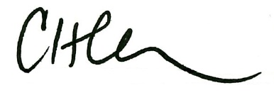
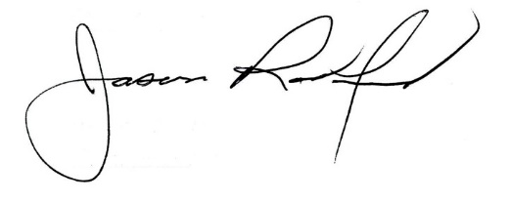

Carly Clem, Board Chair Jason Radford, Superintendent/Secretary

