ACTION ITEM C-1
March 24, 2025
OLDHAM COUNTY BOARD OF EDUCATION
CONCERN
Scheduled days for the 2025 – 2026 Teacher Workdays
DISCUSSION
Prior to the Spring 2025 Roadshow, staff were asked to provide feedback pertaining to the schedule of the 2024-2025 Teacher Workdays. Specifically, the use of the safe schools training day/ Vector Day in late August. Of the 983 responses received, 50.4% completed the training on the assigned day and 49.6% completed on their own time. The questions were then asked if they preferred:
Option 1: Maintain the current system. (57.9%)
Option 2: Convert all five days into traditional teacher workdays. (10.2%)
Option 3: Move Vector Day to before the start of school. (21.1%)
Option 4: N/A this does not apply to me. (10.8%)
Current System: Safe schools’ day the end of August, Late September Teacher Workday, first day back from Winter Break is a staff workday, 2 spring Teacher Workdays.
RECOMMENDATION
Approve the recommendation to maintain the current structure of Teacher Workdays for the 2025-2026 school year.

On a motion by _______________, seconded by _______________, the Board approved to maintain the current structure of Teacher Workdays for the 2025-2026 school year. ( , )

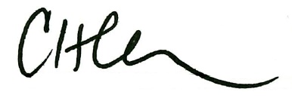
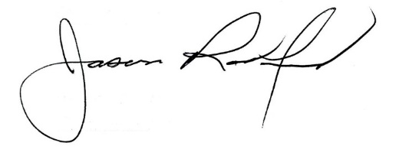

Carly Clem, Board Chair Jason Radford, Superintendent/Secretary

