ACTION ITEM B
March 24, 2025
OLDHAM COUNTY BOARD OF EDUCATION
CONCERN
Consider Approval of FY25 OCS High School Graduation Dates, Times & Locations – 2 options presented.
DISCUSSION
The following 2025 OCS High School Graduation ceremonies options are presented.
SCHOOL | DATE | TIME | LOCATION
Liberty Academy | Fri., May 30, 2025 | 4:00 P.M. | OCS Arts Center
Buckner Alt. High | Fri., May 30, 2025 | 7:00 P. M. | OCS Arts Center

SCHOOL | DATE | TIME | LOCATION
OPTION 1 – SATURDAY MAY 31, 2025
North Oldham High | Sat., May 31, 2025 | 10:00 A.M. | Kentucky Convention Center
South Oldham High | Sat., May 31, 2025 | 1:30 P.M. | Kentucky Convention Center
Oldham Co. High | Sat., May 31, 2025 | 5:00 P.M. | Kentucky Convention Center
SCHOOL | DATE | TIME | LOCATION
OPTION 2 – SUNDAY, JUNE 1, 2025
North Oldham High | Sunday., June 1, 2025 | 11:30 A.M. | Kentucky Convention Center
South Oldham High | Sunday., June 1, 2025 | 2:30 P.M. | Kentucky Convention Center
Oldham Co. High | Sunday., June 1, 2025 | 5:30 P.M. | Kentucky Convention Center
RECOMMENDATION
Board approval of one option for the FY25 Graduation date and times and authorize the Superintendent to execute the necessary documentation.

On a motion by _______________, seconded by _______________, the Board approved the 2025 OCS High School Graduation Dates, Times & Locations and authorize the Superintendent to execute the necessary documentation. ( , )
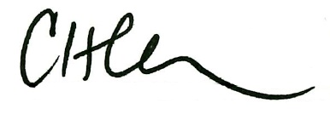
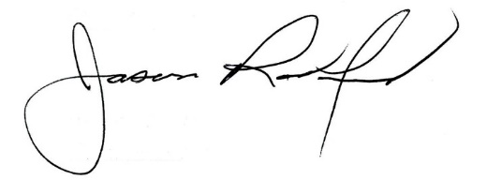

Carly Clem, Board Chair Jason Radford, Superintendent/Secretary

