ACTION ITEM A
March 24, 2025
OLDHAM COUNTY BOARD OF EDUCATION
CONCERN
Proposed FY26 calendar and major break days for FY27.
DISCUSSION
The calendar committee has met this school year. The committee is presenting a calendar for the FY26 school year. The calendar will have 170 student instructional days and five staff workdays. The calendar meets the state requirement of 1062 instructional hours. The first day for student would be August 13, 2025, and the final day for student will be May 22, 2026, barring any days missed for weather. The committee worked with the approved major breaks approved last school year.
Current highlights for the 2025-2026 calendar,
- First day of school August 13, 2025
- Fall Break October 20 to October 24, 2025
- Winter Break December 22, 2025, to January 2, 2026
- Spring Break April 6 to April 10, 2026
- Five Staff Workdays – August 29, September 26, January 5, February 13, and March 13.
- Last day of school – May 22, 2026
- The 5 designated make-up days are May 26, May 27, May 28, May 29 and June 1
The Committee is also recommending major breaks for FY27.
Major Breaks identified for FY27 calendar:
- Fall Break October 19 to October 23, 2026
- Winter Break December 21, 2026, to January 1, 2027
- Spring Break March 29 to April 2, 2027
RECOMMENDATION
Approve the FY26 Calendar and FY27 Major Breaks as presented.

On a motion by _______________, seconded by _______________, the Board approved FY26 Calendar and FY27 Major Breaks as presented. ( , )

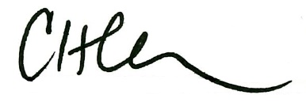
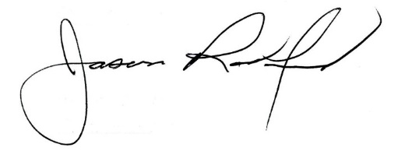

Carly Clem, Board Chair Jason Radford, Superintendent/Secretary

