CONSENT ITEM G
March 24, 2025
OLDHAM COUNTY BOARD OF EDUCATION
CONCERN
Consider the Approval of a Summer Food Service Program for the La Grange area.

DISCUSSION
School districts may sponsor Summer Food Service Programs (SFSP) in the summer months when school is not in session. These programs target students who are eligible for free or reduced-price meals at school. The district school nutrition staff are responsible for organizing the program, preparing and monitoring the sites, and preparing claims for reimbursement. They serve the food to children that reside in the district that are 18 years old or younger. These students receive the meals without cost. Young adults ages 19-21 with disabilities are also eligible.
The School Nutrition Department would like to continue the SFSP at LaGrange Elementary School. Our district qualifies for the program based on the free/reduced percentage of the student body at La Grange Elementary.
The School Nutrition Department will provide breakfast and lunch at LaGrange Elementary.
The following is a list of the sites where meals will be served:
- La Grange Elementary School
RECOMMENDATION
Approve the proposed Summer Food Service Program for the La Grange area for the summer of 2025.

On a motion by _______________, seconded by _______________, the Board approved the proposed Summer Food Service Program for the La Grange area for the summer of 2025.. ( , )


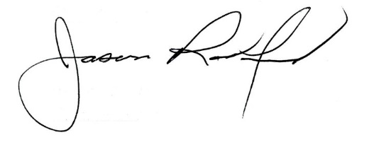

Carly Clem, Board Chair Jason Radford, Superintendent/Secretary

