MINUTES
March 24, 2025
OLDHAM COUNTY BOARD OF EDUCATION

CONCERN
Consider Approval of Meeting Minutes.

DISCUSSION
The draft minutes of the February 24, 2025 – Regular Board Meeting, March 4, 2025 – Special Called Meeting, March 13, 2025 – Special Called Work Session are available for review and approval.

RECOMMENDATION
Approve the minutes of the following meetings as presented.

February 24, 2025 – Regular Board Meeting
(1) Carly Clem, Chairperson, (2) Allison Sheffer, Board Vice Chairman; (3) Suzanne Hundley, Board Member (4) Joe Dennis, Board Member; (5) Adam Springer, Board Member, and Dr. Jason Radford, Superintendent and Secretary to the Board were present.

March 4, 2025 – Special Called Meeting
(1) Carly Clem, Chairperson, (2) Allison Sheffer, Board Vice Chairman; (3) Suzanne Hundley, Board Member (4) Joe Dennis, Board Member (virtual attendance); (5) Adam Springer, Board Member, and Dr. Jason Radford, Superintendent and Secretary to the Board were present.

March 13, 2025 – Special Called Work Session Meeting
(1) Carly Clem, Chairperson, (2) Allison Sheffer, Board Vice Chairman; (3) Suzanne Hundley, Board Member (4) Joe Dennis, Board Member; (5) Adam Springer, Board Member, and Dr. Jason Radford, Superintendent and Secretary to the Board were present.

On a motion by _______________, seconded by _______________, the Board approved the minutes of the February 24, 2025 – Regular Board Meeting. ( , )
On a motion by _______________, seconded by _______________, the Board approved the minutes of the March 4, 2025 – Special Called. ( , )
On a motion by _______________, seconded by _______________, the Board approved the minutes of the March 13, 2025 – Special Called Work Session. ( , )

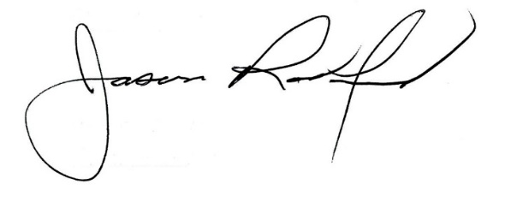
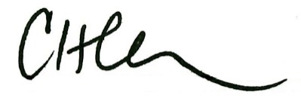

Carly Clem, Board Chair Jason Radford, Superintendent/Secretary

