OLDHAM COUNTY BOARD OF EDUCATION
SPECIAL CALLED MEETING
March 13, 2025
Oldham County District Office
6165 W HWY 146, Crestwood, KY 40014
Attendance Taken at: 4:30 PM
Present Board Members:
Mrs. Suzanne Hundley
Ms. Carly Clem
Ms. Allison Sheffer
Mr. Adam Springer
Mr. Joe Dennis
- CALL MEETING TO ORDER
Chairperson Clem called the meeting to order at 4:45 pm.
- APPROVE AGENDA
Motion Passed: Approval of the Agenda passed with a motion by Allison Sheffer, seconded by Joe Dennis. 5 Yeas - 0 Nays.
- SUPERINTENDENT REPORTS
- Matt Jacobson, High School Level Director, discussed the options for FY25 graduation.
- Eric Davis, Director of Student Support Services, discussed safety options.
- Brent Deaves, Interim Deputy Superintendent, discussed employment engagement.
- Jason Radford, Superintendent discussed policy revisions.
The board took all super reports under advisement.
- ADJOURN
With no further business to discuss, Chairperson Clem called for a motion and second to adjourn. On motion by Allison Sheffer, seconded by Suzanne Hundley, the Board adjourned the February 13, 2025, special called meeting at 6:32 p.m. 5 Yeas - 0 Nays


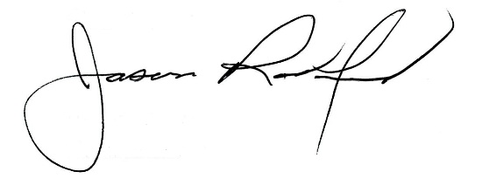

Carly Clem, Board Chair Jason Radford, Superintendent/Secretary

