OLDHAM COUNTY BOARD OF EDUCATION
SPECIAL CALLED MEETING
March 4, 2025
Oldham County District Office
6165 W HWY 146, Crestwood, KY 40014
Attendance Taken at: 4:30 PM
Present Board Members:
Mrs. Suzanne Hundley
Ms. Carly Clem
Ms. Allison Sheffer
Mr. Adam Springer
Mr. Joe Dennis attended virtually by facetime due to internet connection issues.
- CALL MEETING TO ORDER
Chairperson Clem called the meeting to order at 4:45 pm.
- APPROVE AGENDA
Motion Passed: Approval of the Agenda passed with a motion by Suzanne Hundley, seconded by Adam Springer. 5 Yeas - 0 Nays.
- SUPERINTENDENT REPORTS
- Brent Deaves, Interim Deputy Superintendent, discussed the options for amending the FY25 school calendar. The board took all super report under advisement.
- ACTION ITEMS
- Motion Passed: On a motion by Allison Sheffer, seconded by Joe Dennis, the Board approved the changes to the FY25 calendar as presented. 4 Yeas - 1 Nays; Suzanne Hundley opposed.
Change the March 14th teacher workday to a student school day.
- The students’ last day will be Wednesday, May 28, 2025.
- Teacher workday makeup will be Thursday, May 29, 2025.
- The closing day will be Friday, May 30, 2025
- ADJOURN
With no further business to discuss, Chairperson Clem called for a motion and second to adjourn. On motion by Allison Sheffer, seconded by Suzanne Hundley, the Board adjourned the February 4, 2025, special called meeting at 5:02 p.m. 5 Yeas - 0 Nays

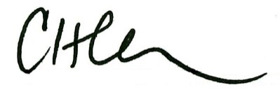
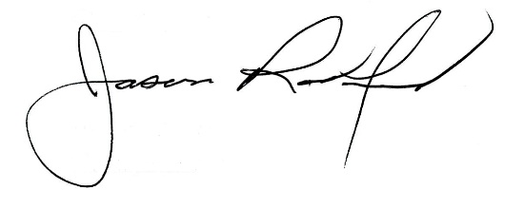

Carly Clem, Board Chair Jason Radford, Superintendent/Secretary

