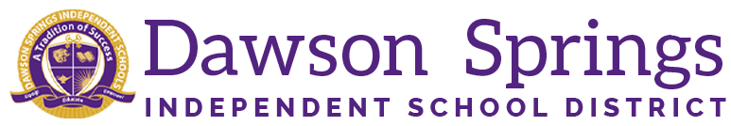

Dawson Springs Elementary School
Where the teachers and students give 100% every day and failure is not an option.
Panthers Prowling to Proficiency!

March 2025 Board Meeting
Elementary Principal Report
Jennifer Ward

- Academic Progress
  - We held our spring Parent Teacher conferences on March 11. We hosted 115 families for this event.
    - Shout out to our PTO and Casey’s for providing us with delicious cookies for this event.
  - RTI data has been reviewed and we have adjusted schedules for students who are receiving services. Services being provided are based on the iReady performance on the winter diagnostic. We use those results to determine what skills students need to work on more in depth. For example, we are using Heggerty for phonemic awareness and the iReady teacher toolbox to address the areas of phonics, high frequency words, and vocabulary, and comprehension. We are also utilizing book studies and independent practice for those students who are advancing in the classrooms.
- PLC Conversations for the Month:
  - Tier 3 RTI data is still being monitored to ensure we are meeting the needs of all of our students.
    - Small group pull-outs are occurring daily to meet needs in both reading and math.
    - As you heard earlier, we have revisited our RTI instruction since the last iREady diagnostic and have made changes accordingly.
  - KSA preparation continues
    - Extended response questions are being administered weekly in tested grades
    - Spring Mock KSA assessment will begin on Friday and go through March 28. The format will mirror the KSA exam for the end of the year along with accommodators and who they will be servicing.
  - 2025/2026 Plans are starting to get underway
    - As of right now there are approximately 50 preschool students coming up to kindergarten.
    - Master schedules are being made at this time.

- Upcoming Events:
  - Spring Break March 31 - April 4, 2025
  - Wednesday, April 9, 2025 - “6th” grade orientation in the middle school
  - iReady Spring Administration window opens on April 14, 2025
  - Tuesday, May 6 - Friday, May 23 - KSA Testing

