FIELD OBSERVATION REPORT

New West Middle School - Cecilia, KY 202280 - CA8
Date: February 26, 2025 Time: 12:30 PM
Weather: 50s/ Partly Cloudy
Observed by: Joseph Jones, AIA Report No: 6
Estimated Completion: 12%
Present on Site:
Kevin Beeler (Wehr Constructors)
East and Westbrook Construction (General Trades), Bailey’s Masonry, Kight’s Plumbing, AES (Electrical), Phillips Brothers (Storm Piping) Withers (Geothermal Well Drillers)
Work in Progress
  - A considerable amount of work had been done despite a very rainy period.
  - Masons had laid the first course of CMUs on the interior footings for most of the building.
  - Footing and stem walls were complete.
  - Plumbers and electricians continued to install under slab utilities.
  - Geothermal well drillers were drilling wells and placing piping in wells.
  - Meetings were held to discuss the installation of concrete slabs to be covered with floor finishes and slabs to have a polished finish.

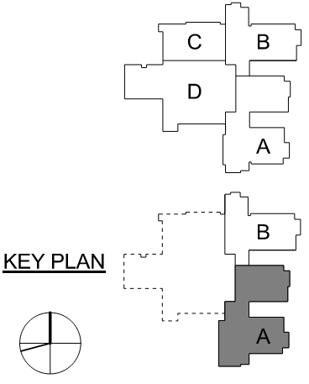

General Observations

Item No. | Location | Description/  Correction | Image | Action
 | Loading Dock Area | Plumbers were installing storm piping near the face of the loading dock. | 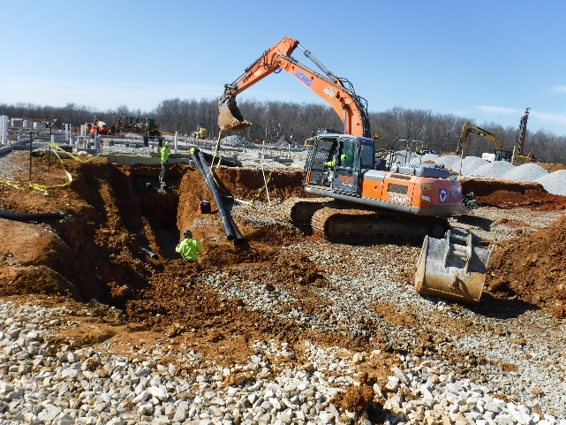 | Indicate all below pavement lines on the as-built drawings.
 | Geothermal Well Field | The drillers were employing two rigs. | 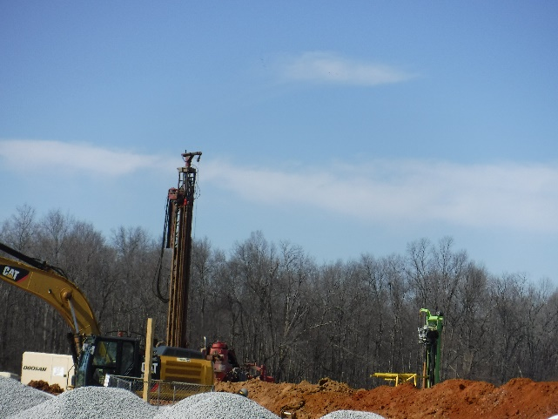 | Keep drilling logs updated and submit to all parties.
 | Area C  Kitchen | The northwest corner of the kitchen includes non-food storage, the staff locker room, staff toilet and managers office. | 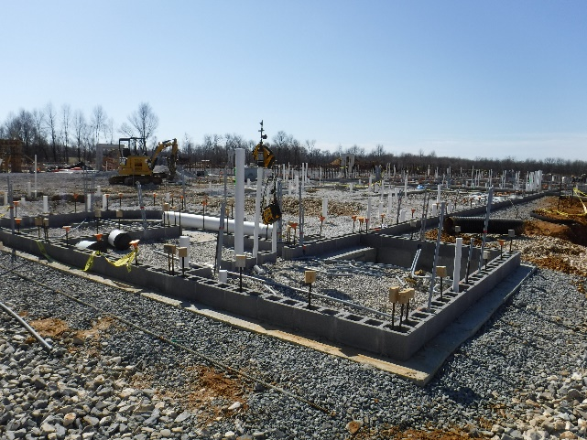 | Prepare exterior block walls for brick veneer.
 | Area C  Kitchen | The room with the angled wall is the kitchen managers office. | 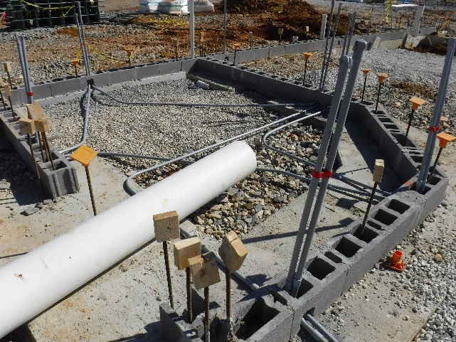 | Install outlets are indicated for the managers furniture layout.
 | Area C  Kitchen | Foreground is the cooking area of the kitchen. | 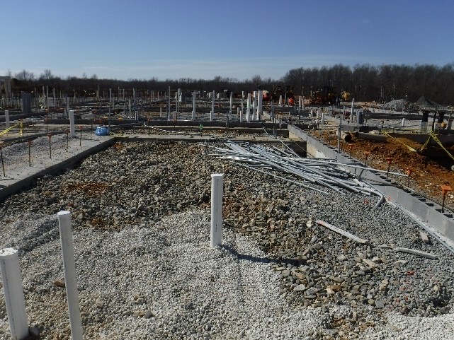 | Coordinate utilities with the submittals for the cooking equipment.
 | Area D | Foreground is the dishwash room looking across to the corridor to the gym/storm shelter. | 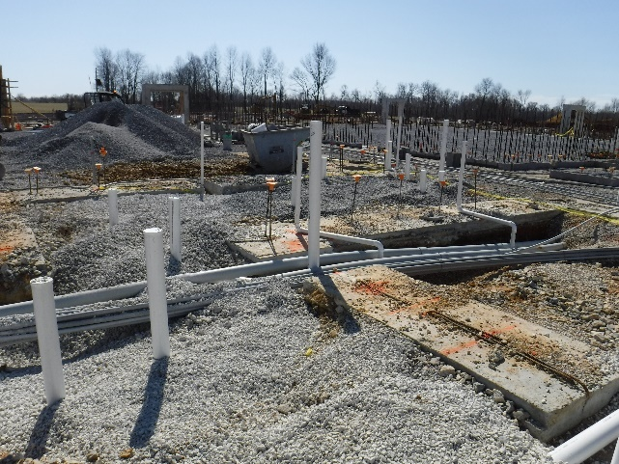 | Layout dishwash equipment per the equipment submittals.
 | Area D | Group toilets, custodian receiving and the mechanical room are to the left. The exit to the dock is in the center. | 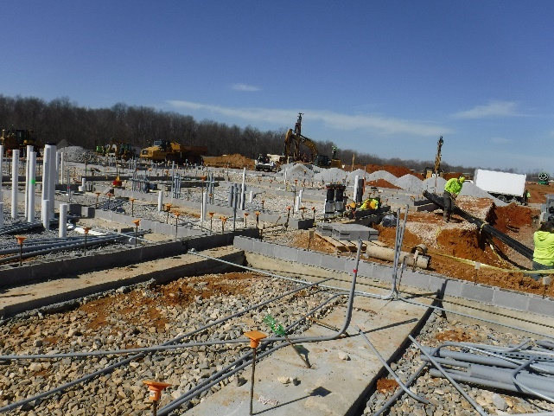 | Install utilities to meet maintenance access requirements.
 | Area D  Toilet Group | The plumbing serves the fixtures for the student toilets. | 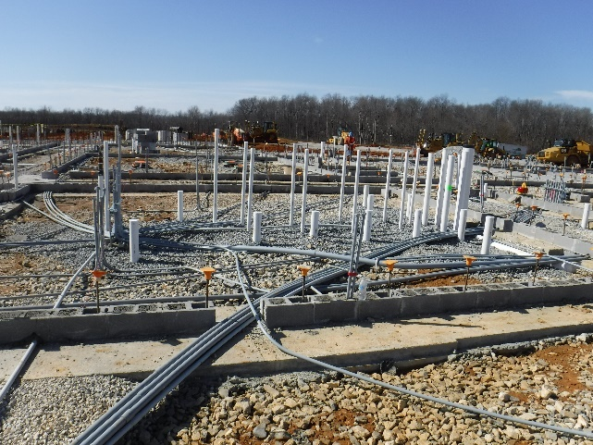 | Plan toilet fixture layouts to comply with ADA requirements and clearances.
 | Area D  South Corridor | Gym storage and coaches offices are to the left and the art room is to the right. | 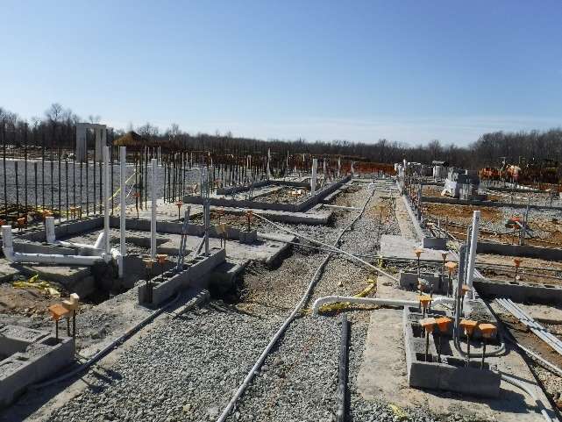 | Locate utilities to serve devices and casework along the walls in the rooms.
 | Area D  Staff Toilets | Under slab plumbing serves the fixtures in these rooms. | 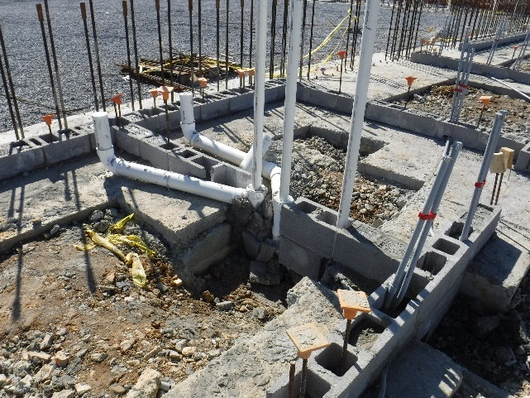 | Install plumbing fixture to meet ADA requirements and clearances.
 | Area D  West Gym Entrance | This entrance two doors separated by a block pier. | 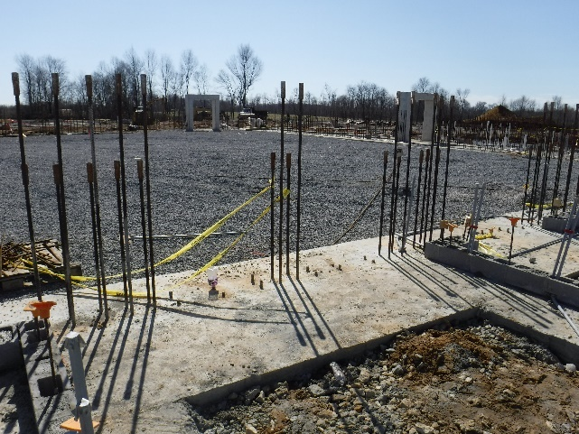 | Install door frames in compliance with storm shelter requirements.
 | Area D Looking West  Computer Classroom is to the Left and Group Toilets are to the Right | The walls in this are form the corridor back to the music rooms. | 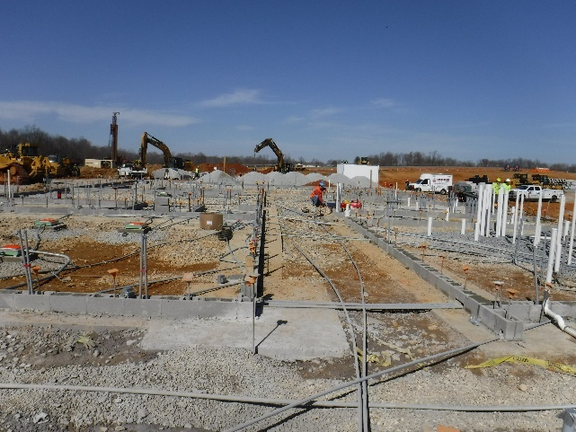 | Prepare slabs for the respective finishes in this area.
 | Area D Vestibule Looking North | The vestibule empties out onto a walk beside the loading dock area. The mechanical room is to the right. | 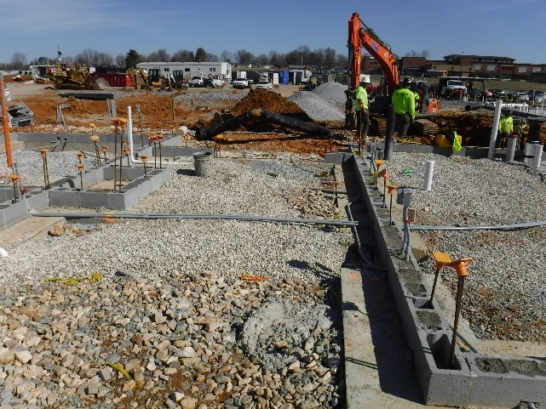 | Pour slabs at exterior doors to provide full anchorage of the thresholds.
 | Technology  Computer Classroom Floor Box | The floor box provides data and power connections for the center of the room. | 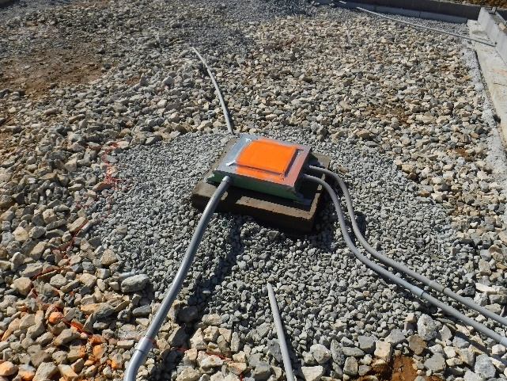 | Protect floor boxes during construction.
 | Area D  MDF Room | Walls in this are concrete block. The MDF room is surrounded with block. | 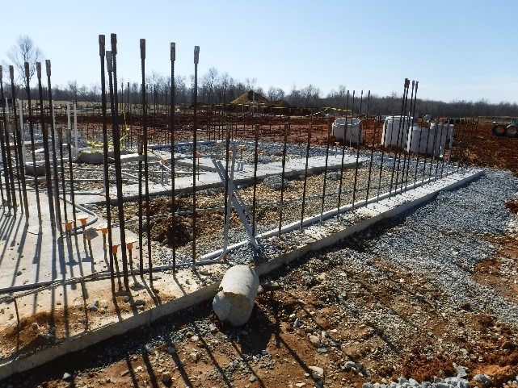 | Plan for data cabling penetrating the MDF walls.
 | Area D  West Corridor Looking North | Sanitary sewer lines run under the corridor slabs. | 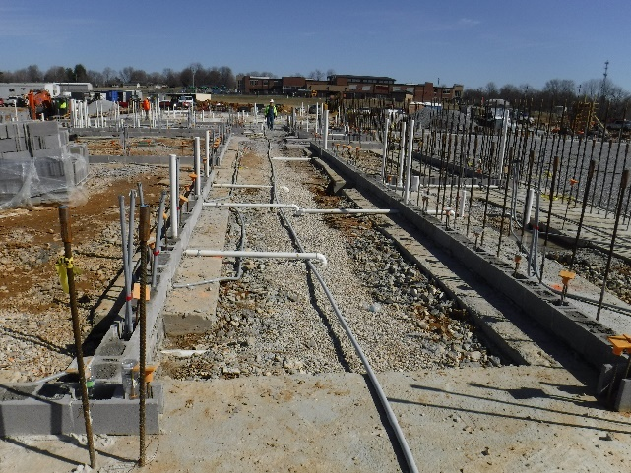 | A third party inspector will verify the slope of the sewer piping under the floor slabs.
 | Door Portal at Gym/Storm Shelter | The storm shelter is formed with block intersecting the concrete door portals. | 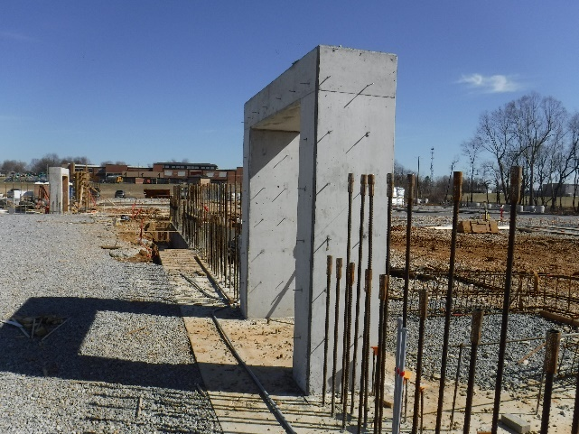 | Plan for expansion joints at the concrete portals.
 | Area A  Administrative Area | The footings reflect that the area is surrounded with block construction. The interior is divided by wallboard partitions. The records room is block. | 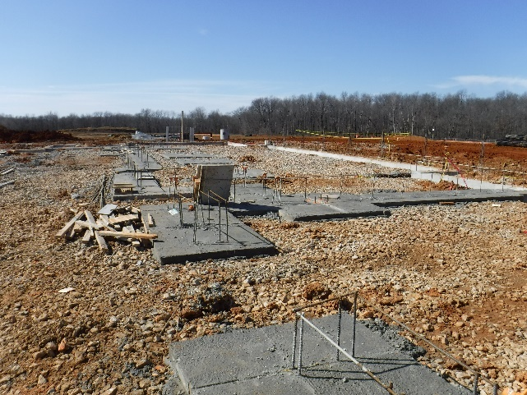 | Located under slab utilities to feed devices in wallboard partitions.
 | Area B  Classroom Wing | The first course of block was in place to receive the floor slab. | 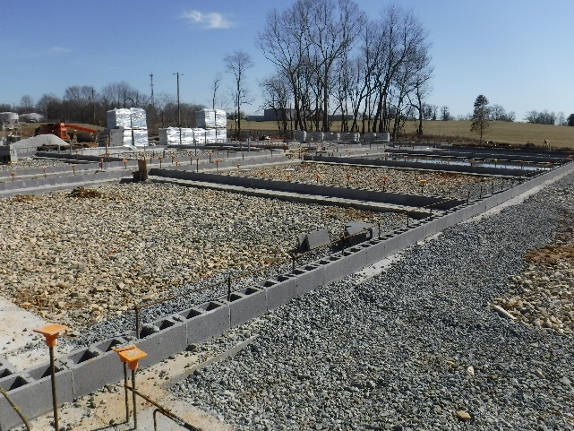 | Incorporate the comments from the pre-slab meeting.
 | Elevator Pit | The concrete pit walls form the foundation for the elevator shaft. | 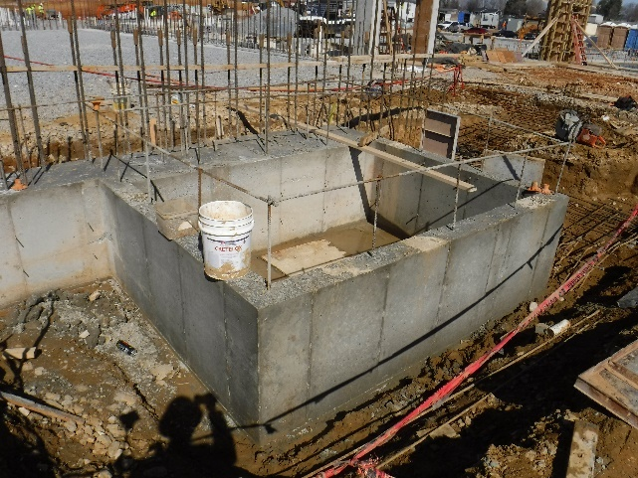 | Verify compliance with requirements of the elevator manufacturer.

- Stored Material:

  - Concrete storm piping and structures and accessories.
  - Concrete accessory materials to construct the foundations and floor slabs.
  - Reinforcing steel and accessories.
  - Crushed stone for pavement areas and back fill for plumbing trenches.
  - Masonry accessories and CMUS.
  - Geothermal piping.
  - Sanitary piping and fittings.
  - Electrical conduits and fittings.

- Follow up items:

  - Keep as-built locations for site utilities up to date on the as-built drawings.
  - Keep as-built locations of mechanical, plumbing, and electrical system locations up to date on the as-built drawings.
  - Correct and address all action items and deficiencies and submit a log to JRA confirming that the work has been completed.

Respectfully submitted,
Joseph Jones, AIA
JRA Architects
Cc: 202280, CA8

