Director of Support Services
Board Report - March 2025
Submitted by Katrina Rechtin
Director of Pupil Personnel
BISD 2024-25 Enrollment
(Numbers pulled from Infinite Campus on March 12, 2025)
GES |  | BMS/BHS
Preschool | 55 | 6 | 28
K | 37 | 7 | 34
1 | 39 | 8 | 26
2 | 31 | 9 | 56
3 | 32 | 10 | 39
4 | 32 | 11 | 53
5 | 32 | 12 | 57
Total | 258 | Total | 293
BISD Total Enrollment Preschool - 12th Grade: 551
BISD Total Enrolment Kindergarten-12th Grade: 496
The numbers shown above are based on current enrollments.
2024-25 BISD Enrollment Summary
Month | Grandview Elementary | Bellevue High School | District
End of 23-24 School Year | 266 | 335 | 601
August 2024 | 256 | 318 | 574
September 2024 | 253 | 307 | 560
October 2024 | 252 | 301 | 553
November 2024 | 251 | 300 | 551
December 2024 | 251 | 299 | 550
January 2025 | 250 | 297 | 547
February 2025 | 251 | 295 | 546
March 2025 | 258 | 293 | 551

BISD Attendance
 | GES | BMS/BHS
August (8/15-8/31) | 95.99% | 95.23%
September (9/1 - 9/30) | 96.44% | 93.96%
October (10/1-10/31) | 94.39% | 92.08%
November (11/1-11/30) | 94.49% | 92.37%
December (12/1-12/20) | 93.68% | 92.66%
January (1/1 - 1/31) | 93.26% | 92.31%
February (2/1-2/28) | 92.44% | 93.27%
March (3/1-3/12) | 92.77% | 94.66%
August 15th - March 12th | 94.27% | 93.29%
District Attendance Percentage - August 15, 2024 - March 12, 2025 - 93.68%
I have created a new attendance tracking sheet, which you can access HERE. This sheet breaks down attendance by month, week, and school, and provides an overview of district-wide attendance. I will update this document every Friday.
District Wide Attendance Challenge
Just like last year, we will be holding our districtwide March Madness Attendance Challenge. The bracket is shown in the image below. The challenge will begin the week of March 17th and conclude on April 4th.
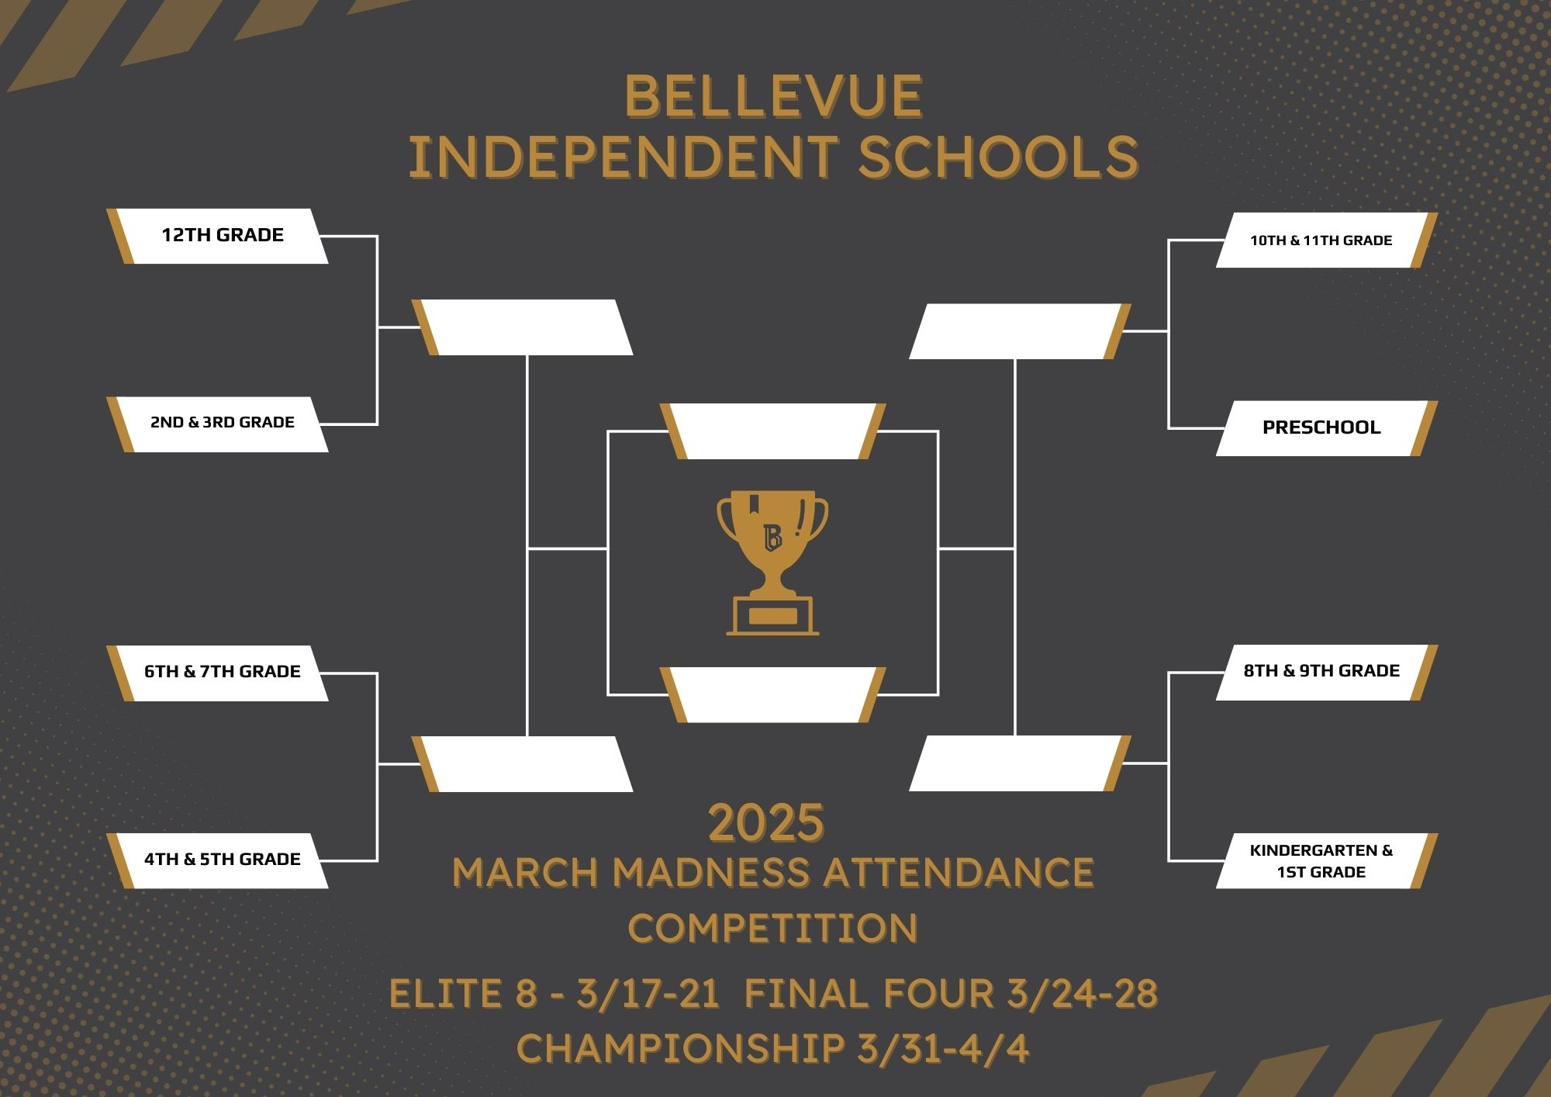
Infinite Campus
I am currently setting up the 2025–2026 school year in Infinite Campus, following the calendar’s approval at the February board meeting. Once the school year setup is complete, we can begin working on the scheduling process for the 2025–2026 school year.
Recruitment/Retention Initiatives
The Communication Coordinator and I are still working on completing a video series highlighting the outstanding initiatives and achievements within the Bellevue Independent School District. Our goal is to engage both current families and those who have not yet joined the Bellevue community, especially as we approach open enrollment and our open house events in March. Our last video will be published next week before the open house event at BHS.
So far, we have released four videos, with the following lineup planned for the series:
- Why Do You Love Bellevue? (released 1/28/25)
- Athletics (released 2/10/25)
- Extracurricular Opportunities (released 2/24/25)
- Academics (released 3/10/25)
- Facilities (anticipated release date 3/19/25)
We are also planning a sixth video in the series, focusing on our early childhood initiatives. This will highlight programs such as Future Tiger Bags, the Tiger Cubs book program, the Dolly Parton Imagination Library, and our exceptional preschool program. We aim to release this video alongside an opportunity for families to schedule preschool screenings for the 2025–2026 school year.
Kindergarten Registration Events
Our kindergarten registration events were very successful. Families actively participated in the scavenger hunt and enjoyed meeting the administration and school staff while learning about the opportunities Grandview offers. They particularly enjoyed visiting the kindergarten classrooms and meeting our kindergarten teachers.
FRYSC/YSC District Update
There are many wonderful things happening in both of our buildings, and we are fortunate to have Rob Sanders and Danielle Carr leading the way.
Please see the updates and information below from each building coordinator:
Rob Sanders - Grandview Elementary Family Resource Center
We are currently working on several year-end tasks. This includes completing state-required end-of-year reports, preparing the Food Pantry for the year-end site visit, reducing and removing overstock and non-moving items from the FRC at both schools, and cleaning up data files.
Danielle Carr, Bellevue High School Youth Service Center
We are currently planning a series of summer family events. These will include a movie theater rental featuring Karate Kid: Legends, a bowling alley rental, and take-home painting kits. Each event will likely have a different resource theme, such as mental health resources, physical health resources, and possibly a third theme that is still being decided.

