Strategic Prevention Framework
I³: Inspired, Individualized, Inclusive
February 2025 - March 2025
Goal: To reduce the onset & progression of substance misuse & its related problems in Bellevue, KY, by supporting the development & delivery of community substance misuse prevention & mental health promotion services.
Objective 1: | By 9/29/2027, reduce the 30-day use of alcohol among tenth-grade students by 2% each year as measured by annual KIP survey data.
Objective 2: | By 9/29/2027, reduce regular (30-day) vaping use among tenth-grade students by 2% each year as measured by annual KIP survey data.
Objective 3: | By 9/29/2027, reduce regular (30-day) cigarette smoking among tenth-grade students by 2% each year as measured by annual KIP data.
Objective 4: | By 9/29/2027, tenth-grade students reporting serious psychological distress, according to the K6 KIP data, will decrease by 4% each year.
Objective 5: | By 9/29/2027, expand collaboration with community prevention partners, demonstrated by support from community prevention partners at least 2x each year in the project’s family prevention education opportunities, documented by photographic evidence & meeting notes.

ASSESSMENT
Accomplishments | Description | Align
Assessment of schools’ capacity: | Data Analyst completed focus groups with GES PLC groups to gather quantitative data about barriers and concerns when collecting SEB progress monitoring data.  - This data will be reviewed and utilized to develop a progress monitoring data collection process for the next academic year that is more effective and manageable for teachers.  - Data Analyst will continue to meet with the PLC groups to teach and guide teachers in SEB data collection for the rest of this year. Data Analyst will continue to collaborate with teachers to create progress monitoring process as well. | 1-5
Monitoring schools needs assessment activities: | Internal Referrals for mental health services. *  0 internal referrals for services (GES only)  0 internal referral accepted  0 internal referral in progress  2 students fading out of services  2 internal referrals for prevention services  2 internal referral assessment completed for prevention services  BMHS MTSS Tracker  GES MTSS Tracker  *Specific BMHS mental health referral data and internal referral assessments unknown | 1-4
Monitoring schools needs assessment activities: | External Referrals for mental health & prevention services. *  0 student/family external referral  2 student/family Care Solace referrals  0 staff member's Care Solace referrals  *Specific BMHS external referral data unknown | 1-4
Monitoring schools needs assessment activities: | Grant staff collect & monitor data on all grant lead initiatives. This includes, but is not limited to:  - Outreach & Engagement Data  - Participation Data  - Outcome Data  - Financial Data  - Progress Monitoring  SPF Data | 1-5
Use of needs assessment data: | Grant staff continues to redirect efforts to target the community with infrastructure development initiatives. | 5
CAPACITY
Accomplishments | Description | Align
Professional Development: | SPF Grant Staff:  - UK CTAC Trauma-Informed Practices for Educators Learning Collaborative Learning  - Low-Burden, High-Impact Practices to Promote Well-Being, Belonging, and Academic Engagement – Character Strong  - Navigators of the Commonwealth - UK Center on Trauma and Children  - Safe Roads Ahead: How to Discuss Impaired Driving with Children and Teens  - Lunch & Learn Stop Smoking Mindfully – University of Kentucky  - Unpacking the risks of modern Marijuana-Laura Stack – Operation Parent  - Vaping in 2025: What's Changed and What Parents need to know, Dr. Aaron Weiner  - Session 1 Understanding the SSRA and Resource Mapping - UK Center on Trauma and Children  - Session 2: Writing Smart Goals - UK Center on Trauma and Children  - Creating and Implementing Trauma-Informed Plans: Technical Assistance - UK Center on Trauma and Children  - Mental Health Action Day Partner Kickoff – Mental Health of America Taskforce  GES Mental Health Professional:  - Creating and Implementing Trauma-Informed Plans-part 1  - The Kindness Crisis-Character Strong  - Creating and Implementing Trauma-Informed Plans-part 2 | 5
Building internal coalitions: | Grant staff participated in the following monthly coalition/committee meetings:  - GES PBIS Tier 2/3 Meeting  - GES Student Care Team Meeting  - GES Arc Meeting  - GES PLC Data Meetings  - Rae of Sunshine - SMILE Club Meetings  - NKCES meetings with Brain Brentlinger  - Mental Health and Prevention Staff and Treatment | 5
Building external coalitions: | Grant staff participated in the following monthly coalition/committee meetings:  - North Key  - NKY ASAP  - SBMH Grant Committee Meeting  - TISS Grant Committee Meeting  - NKISP Steering Committee Meeting  - Campbell County Drug-Free Alliance General Meeting  - River Cities Drug-Free Coalition Meeting  - Madi’s House – Lunch & Learn  - Safety Net Alliance Meeting | 5
Building external partnerships: | Grant staff meet with the following community agencies:  - North Key – Too Good for Drugs Curriculum discussion  - NKY Health Department – Too Good for Drugs Curriculum discussion  - Starbucks  - Character Strong – new data features discussion  - SAMHSA – SPF Carryover discussion  - Kroger  - Trader Joe  - NKCES NKU Resource Fair  - City of Bellevue – Winter Festival | 5
Community Conversations: | - North Key – TGFD Curriculum  - CCDFA to discuss video campaign & Prom initiative  - City of Bellevue - Winter Festival
Other infrastructure development: | - Review & update the MH&Prevention Webpage with resources weekly  - BISD Resource Mapping review & update support for students, staff, & families | 5
PLANNING
Accomplishments | Description | Align
Articulation of a vision for prevention activities: | Grant staff will work with school leadership to discuss the following:  - Implementation of video campaign  - Implementation of Too Good for Drugs | 1-5
Articulation of a vision for prevention activities: | Grant staff are working toward planning the following:  District  - Lockbox Video Campaign with CCDFA and SMILE Club  GES  - Too Good for Drugs Curriculum with NKY Health Department & North Key  BMHS  - SMILE Club  MARCH  - 03/18 – SPF Advisory Board Meeting  - 03/17 – Youth Café Training – Frankfort  - 03/17 – St. Patrick’s Day – SMILE Club  - 03/19 – Trauma Plan - CDIP/CSIP Alignment Training  - 03/21 – Spill the Tea  - 03/21 – Newsletter #4  - 03/24 – NKCES Make & Take Event  - 03/24 - A Youth Suicide Prevention Seminar for Parents & Communities  - 03/31 – Sober Week Campaign  APRIL  - Alcohol Awareness Month  - 04/01 – Take Down Tobacco Day  - 04/02 – KY Tobacco Control Conference  - 04/04 – Prom initiative with CCDFA  - 04/09 – Cannabis and Other Drugs Prevention Conference (Virtual)  - 04/15 – Dinner Table Project #4  - 04/18 – Spill the Tea  - 04/30 – Navigators of the Commonwealth  SPRING  - Classroom Lockbox initiative/video campaign  - NKY Student Mental Health Roundtables  - Newsletters  - Field Day  - Weekly Rae of Sunshine – SMILE Club Meetings  - Mental Health Month  - Mental Health Day of Action | 1-4
Identification of the district-level priorities: | Mental Health & Prevention Services Handbook — I³ team continues to create an evidence-based policy and procedural handbook for BISD’s mental health and prevention services.  - Outlines the screening process  - Details referral process  - Includes information about MTSS | 1-5
Identification/coordination/allocation of resources: | Trauma-Informed Grant – The I³ team is working with NKCES to evaluate the strengths and weaknesses of BISD’s Trauma Plan. The team will review recommendations based on the trauma-informed walkthrough. In a four-part training through, the team is revising the district trauma plan team with UK Center on Trauma and Children. | 4
IMPLEMENTATION
Accomplishments | Description | Align
Specific community-level interventions being implemented: | Grant staff implemented the following:  District  - Lockbox Video Campaign with CCDFA and SMILE Club  - #SEL Day  - MTSS tiered level of support & SEB Screener Capacity & Decision Rules  GES  - Too Good for Drugs Curriculum with NKY Health Department & North Key  - PLC Data Discussion  BMHS  - SMILE Club  FEBRUARY  - 02/17 – Random Acts of Kindness Day  - 02/18 – Dinner Table Project #3  - 02/19 – SMILE Club Concession Stand Fundraisers  - 02/19 – Safety Net Alliance Meeting  - 02/21 – Spill the Tea Initiative  - 02/21 – NKU Resource Fair  - 02/22 – City of Bellevue Winter Carnival  - 02/26 – Navigators of the Commonwealth  - 02/26 – Celeste Nominated Staff of the Month  - 02/27 – Madi’s House Lunch & Learn  - 02/27 – Filming CCDFA Video Campaign  MARCH  - 03/02 – Teen Mental Health Awareness Day  - 03/03 – #SEL Day  - 03/07 – SBMH & TISS Committee Training  - 03/11 – GES Open House  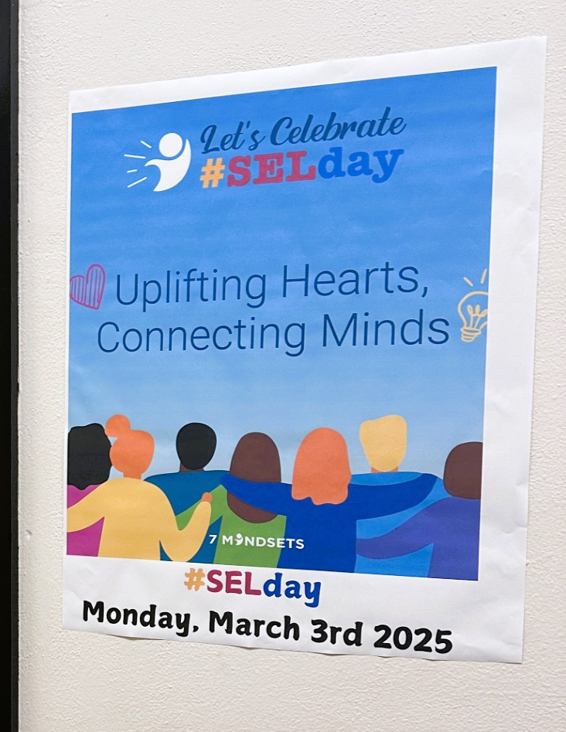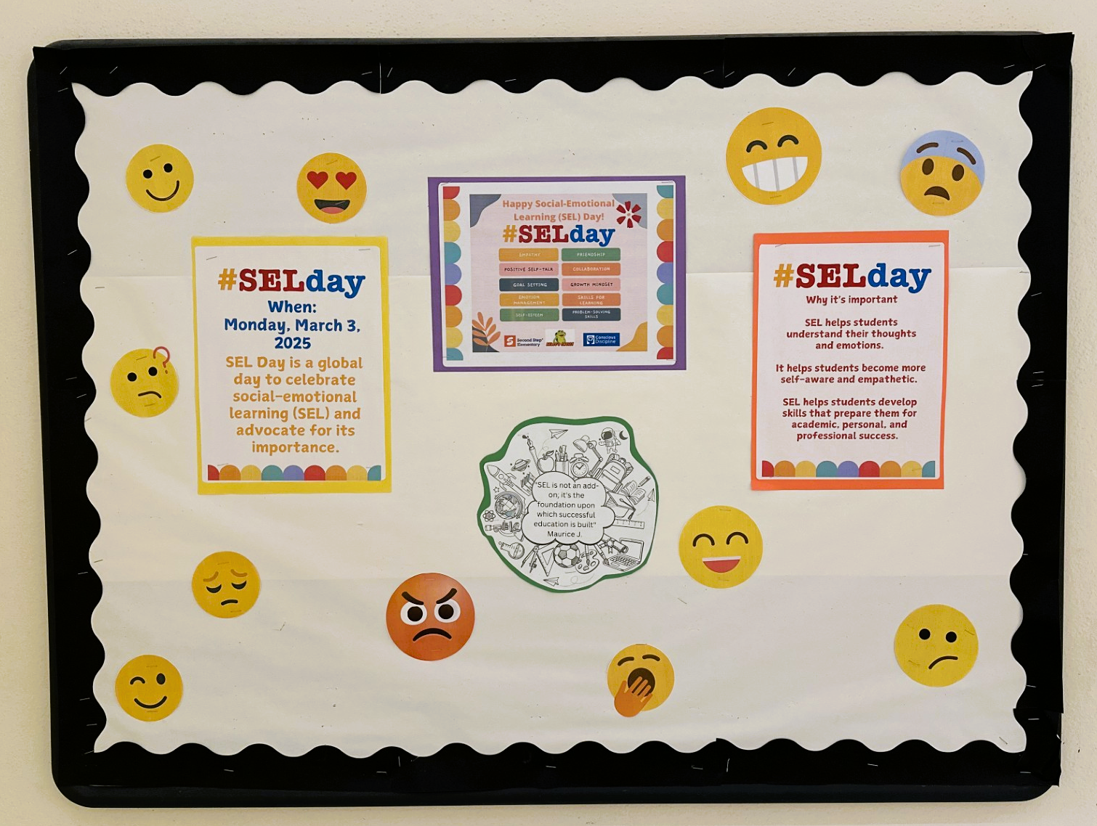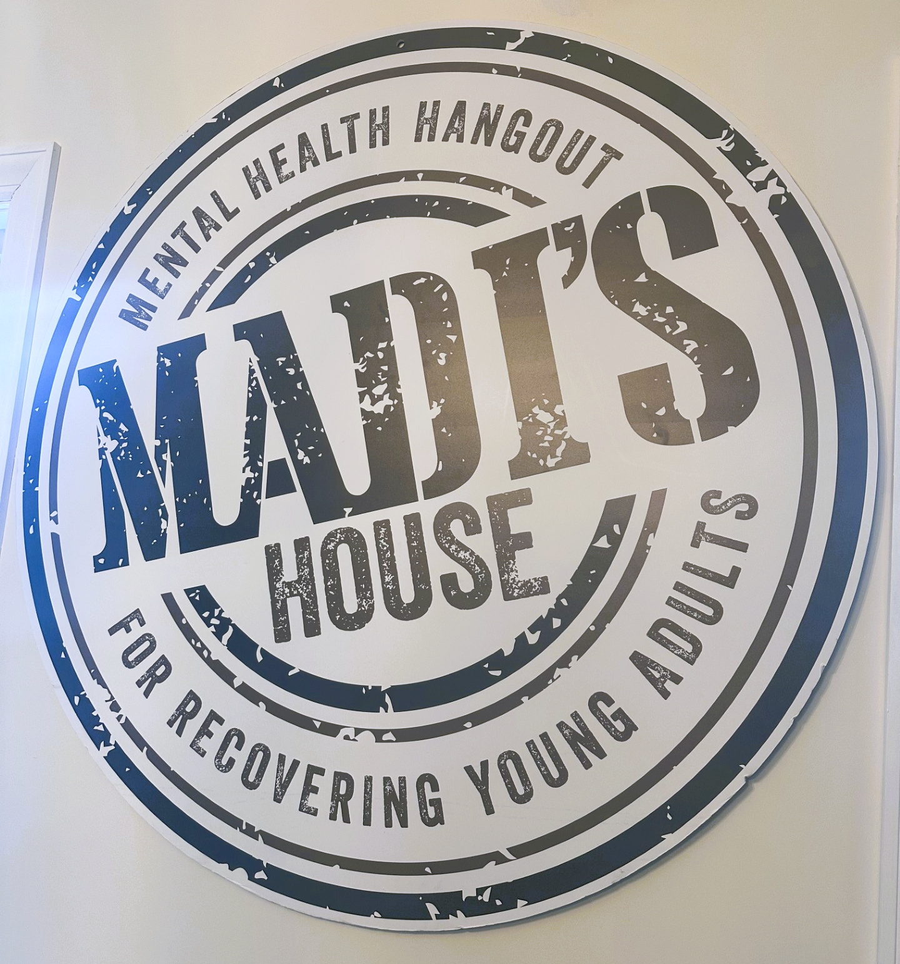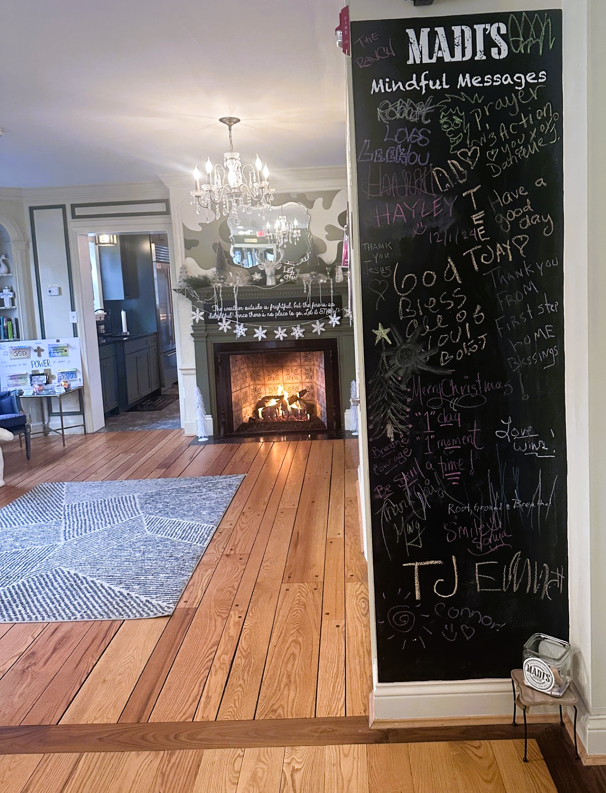  
Implemented policies within organizations to facilitate interventions | Grant staff works with the following grants to create procedures for the BISD mental health & prevention team in response to students' & families' mental health & prevention needs. These align with best practices.  - Trauma-Informed Grant  - Grant staff continues to work with TISS Grant to revise BISD’s trauma-informed plan & create action steps to ensure the implementation of best practices.  - Grant staff continues to work with SBMH Grant to review & revise BISD’s Mental Health plan & create action steps to ensure the implementation of best practices.  - School-Based Mental Health Grant  - Grant staff continues to work with SBMH Grant to review & revise BISD’s Mental Health plan & create action steps to ensure the implementation of best practices.  - Prevention  - Grant staff continues to review & revise BISD’s Prevention plan, creating action steps to ensure the implementation of best practices.  - Created district tobacco/nicotine-free procedure in response to HB-142; the procedure was added to the Code of Conduct and middle/high school behavior matrix. | 4
Specific community-level interventions being implemented: | SBMH Breakdown of time and/or student reached/seen:  - Direct: 2,400 minutes = 40 hours  - Total Sessions: 60  - Extra Sessions: 355 minutes = 6 hours  - Indirect: 1,000 minutes = 16.7 hours  SBMH GES Caseload Numbers:  - Active cases: 19  - Tier 2 performance: 0  - Referrals: 2  - Total referred, awaiting consent in last month: 1  - Total fading out of services in last month: 3 | 4
Specific community-level interventions being implemented: | Prevention Breakdown of time and/or student reached/seen:  - Total sessions: 14  - Total direct sessions: 11  - Total extra sessions: 3  - Groups: 0  - Tier 2 performance: 0  Prevention Caseload Numbers:  - Active cases: 2  - Referrals: 2  - Pending: 1  - Tier 2 performance: 0 | 1-4
Developed systems for distributing resources: | 0 lockboxes distributed to families  - 22 distributed in total  0 deterra bags distributed to families  - 0 distributed in total  - 75 available | 1-3
EVALUATION
Accomplishments | Description | Align
Monitor & evaluate all activities: | Evaluating SEB tier 1/2 data collected to support and inform our developing MTSS | 4
Monitor & evaluate all activities: | Evaluating tier 3 school-based mental health services by using Child Outcome Rating Scale (CORS) and Child Session Rating Scale (CSRS). These tools measure progress made in therapy sessions. Progress monitoring should be reviewed and utilized at Tier 2/3 Meeting | 4
Monitor & evaluate all activities: | SPF Grant Data  - Outcome data collected on the number of event impressions and post-survey information  - Data submitted to SPARS  Total Served to Date = 3,733  Total Interactions to Date = 17,803  Total Reached to Date = 69,707  Pop the Stigma = 582 served, 3620 interactions, 7272 overall reach  Winter Festival City of Bellevue = 100 served, 959 interactions, 1974 overall reach  Extracurriculars Video = 16 served, 611 interactions, 969 overall reach  Total to Date:  Dinner Table Project = 764 served, 2756 interactions, 8705 overall reach  Spill the Tea = 29 served, 982 interactions, 6517 overall reach | 1-5
Monitor & evaluate all activities: | Tracking the occurrence of substance use related office referrals at BMHS since the beginning of the grant; overall, we continue to see a decrease in substance use related office referrals  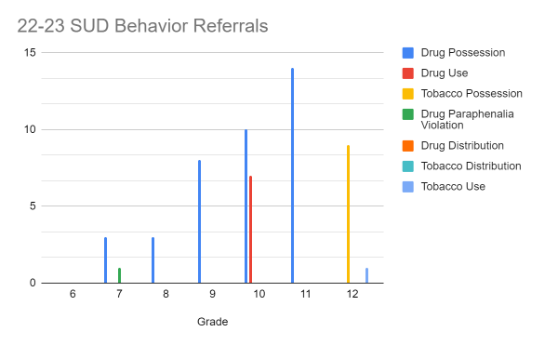  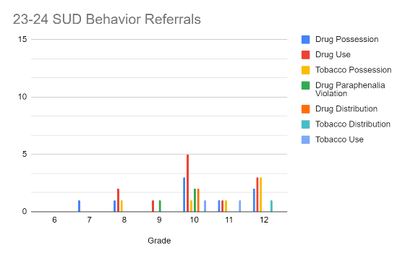  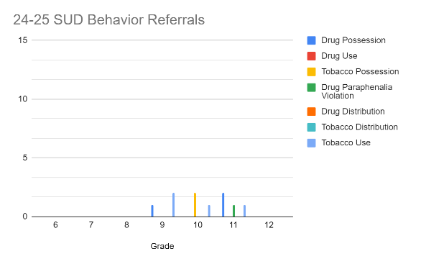  SUD Behavior Office Referral Data | 1-3
Monitor & evaluate all activities: | #iCANendthetrend post-survey #1 collected; will review once results are received from the program.  - Waiting to complete post-survey #2 when received | 1-5
Monitor & evaluate all activities: | Creating process to evaluate outreach data and increased prevention messaging data for this academic year to inform decisions and initiatives for next academic year. | 1-5
Grant Reporting: | - 12/31 – SPF eRa Commons Annual Performance Review – Submitted  - 01/31 – SPF Continuation Report – Submitted  - 03/30 – SPF SPARS Quarter 1 & 2 Report – Due  - 03/06 – SPF eRa Commons Carryover – Approved | 1-5

SUSTAINABILITY
Planning for sustaining the infrastructure: | Continue developing & improving the district's MTSS system & mental health support. SEL teams deliver substance abuse prevention curriculum to students.

