ACTION ITEM A
March 4, 2025
OLDHAM COUNTY BOARD OF EDUCATION
CONCERN
Consider amending the FY25 Calendar due to the impact of extreme winter weather and sickness this winter season.
DISCUSSION
OCS has already taken 10 NTI days - we cannot take anymore as of now 2/20/25.
7 weather NTI days
3 Sickness NTI days
We have taken two traditional days off.
1 weather day off
1 Sick day off
We have 5 hours left in delays.
Proposed Change:
Amend the FY25 calendar: Change the March 14th teacher workday to a student school day.
- Students’ last day will be Wednesday, May 28, 2025.
- Closing day will be Thursday, May 29, 2025.
- Teacher workday makeup will be Friday, May 30, 2025
RECOMMENDATION
Approve the proposed change to the FY25 calendar.

On a motion by _______________, seconded by _______________, the Board approved the proposed change to the FY25 calendar as presented. ( , )


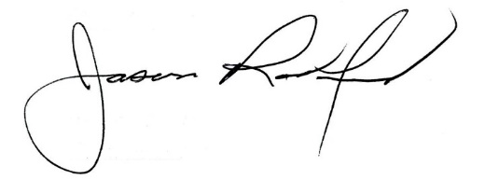

Carly Clem, Board Chair Jason Radford, Superintendent/Secretary

