CONSENT ITEM I
February 24, 2025
OLDHAM COUNTY BOARD OF EDUCATION
CONCERN
Consider approval of Student Athletic Insurance for the 2025/2026 school year.
DISCUSSION
Each year, the district is required to purchase (and has purchased) student athletic insurance to cover liability up to the KHSAA catastrophic injury insurance coverage. In addition, each of the last two years the district has offered individual student insurance at no cost to families without insurance or those who want supplemental coverage.
The Roberts Insurance Group has been our provider and has continued to negotiate with the Zurich insurance company to provide our coverage. The loss ratio for Oldham County Schools last year was 313%, and 103% the year before. Student Accident carries a target of a 65% loss ratio. Even with this ratio the premium will stay the same at $45,301.
They are offering us an increase in coverage to help families who need physical therapy. Our current plan only allows for $1,000 per physical therapy accident but the new cover will increase to $2,000 per accident. The increased cost would only increase our premium $3,512. We have already had several incidents where students need more physical therapy than the plan allows, cost us additional.
RECOMMENDATION
Approve the recommendation of student insurance through the Roberts Group and Zurich Insurance with the increased premium of $3,512 which will increase the physical therapy coverage from $1,000 to $2,000 per accident. The new total cost will be $48,813.

On a motion by _______________, seconded by _______________, the Board approved the student insurance through the Roberts Group and Zurich Insurance with the increased premium of $3,512 which will increase the physical therapy coverage from $1,000 to $2,000 per accident. The new total cost will be $48,813. ( , )


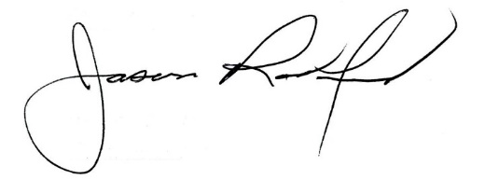

Carly Clem, Board Chair Jason Radford, Superintendent/Secretary

