MINUTES
February 24, 2025
OLDHAM COUNTY BOARD OF EDUCATION
CONCERN
Consider Approval of Meeting Minutes.
DISCUSSION
The draft minutes of the January 22, 2025 - Expulsion Hearing, January 27, 2025 – Regular Board Meeting, January 30, 2025 – Expulsion Hearing; February 4, 2025 – Work Session, February 11, 2025 – Expulsion Hearing, February 13, 2025 – SBDM Reports are available for review and approval.
RECOMMENDATION
Approve the minutes of the following meetings as presented.
January 22, 2025 – Special Called Expulsion Hearing
(1) Suzanne Hundley, Chairperson, (2) Joe Dennis, Board Member, (3) Carly Clem, Board Member (4) Allison Sheffer, Board Member, (5) Adam Springer, Board Member and Dr. Jason Radford, Superintendent and Secretary to the Board were present.
January 27, 2025 – Regular Board Meeting
(1) Suzanne Hundley, Chairperson, (2) Joe Dennis, Board Member, (3) Carly Clem, Board Member (4) Allison Sheffer, Board Member, (5) Adam Springer, Board Member and Dr. Jason Radford, Superintendent and Secretary to the Board were present.
January 30, 2025 – Special Called Expulsion Hearing
(1) Carly Clem, Chairperson, (2) Allison Sheffer, Board Vice Chairman; (3) Suzanne Hundley, Board Member (4) Joe Dennis, Board Member; (5) Adam Springer, Board Member, and Dr. Jason Radford, Superintendent and Secretary to the Board were present.
February 4, 2025 – Special Called Work Session Meeting
(1) Carly Clem, Chairperson, (2) Allison Sheffer, Board Vice Chairman; (3) Suzanne Hundley, Board Member (4) Joe Dennis, Board Member; (5) Adam Springer, Board Member, and Dr. Jason Radford, Superintendent and Secretary to the Board were present.
February 11, 2025 – Special Called Expulsion Hearing
(1) Carly Clem, Chairperson, (2) Allison Sheffer, Board Vice Chairman; (3) Suzanne Hundley, Board Member (4) Joe Dennis, Board Member; (5) Adam Springer, Board Member, and Dr. Jason Radford, Superintendent and Secretary to the Board were present.
February 13, 2025 – Special Called SBDM Meeting
(1) Carly Clem, Chairperson, (2) Allison Sheffer, Board Vice Chairman; (3) Suzanne Hundley, Board Member (4) Joe Dennis, Board Member; (5) Adam Springer, Board Member, and Dr. Jason Radford, Superintendent and Secretary to the Board were present.

On a motion by _______________, seconded by _______________, the Board approved the minutes of the January 22, 2025 – Special Called Expulsion Hearing. ( , )
On a motion by _______________, seconded by _______________, the Board approved the minutes of the January 27, 2025, Regular Board Meeting. ( , )
On a motion by _______________, seconded by _______________, the Board approved the minutes of the January 30, 2025 – Special Called Expulsion Hearing. ( , )
On a motion by _______________, seconded by _______________, the Board approved the minutes of the February 4, 2025 – Special Called Work Session. ( , )
On a motion by _______________, seconded by _______________, the Board approved the minutes of the February 11, 2025 – Special Called Expulsion Hearing. ( , )
On a motion by _______________, seconded by _______________, the Board approved the minutes of the February 13, 2025 – Special Called SBDM Reports. ( , )

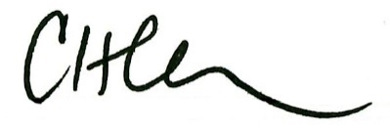
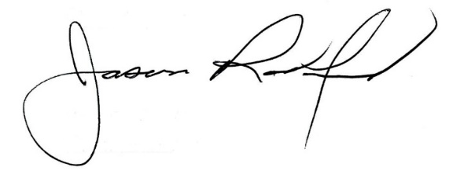
___________________________________ ______________________________
Carly Clem, Board Chair Jason Radford, Superintendent/Secretary

