OLDHAM COUNTY BOARD OF EDUCATION
February 13, 2025, 4:45PM
ARVIN EDUCATION CENTER
1650 Colonels Drive, La Grange, KY 40031
Attendance Taken at: 4:43 PM
Present Board Members:
Mrs. Suzanne Hundley
Mr. Adam Springer
Ms. Carley Clem
Ms. Allison Sheffer
Mr. Joe Dennis
- MEETING CALLED TO ORDER
Chairperson Clem called the meeting to order at 4:45 p.m.
- AGENDA APPROVAL
Chairperson Clem called for motions to approve the agenda; motioned by Allison Sheffer, seconded by Joe Dennis, the Board approved the February 13, 2025, special-called meeting agenda. (5-0).
- SBDM COUNCIL REPORTS
- The Board conducted annual discussions with the SBDM Council from BAHS.
- The Board conducted annual discussions with the SBDM Council from ARVIN.
The board took the reports under advisement, no action was taken.
BREAK
The Board took a short dinner recess at 5:55 p.m. and resumed their meeting at 6:15 p.m.
SBDM COUNCIL REPORTS
- The Board conducted annual discussions with the SBDM Council from NOHS.
- The Board conducted annual discussions with the SBDM Council from SOHS.
- The Board conducted annual discussions with the SBDM Council from OCHS.
The board took the reports under advisement, no action was taken.
- ADJOURN
With no further business to discuss and acting on the Superintendent's recommendation to adjourn, Chairperson Clem, called for motions. On a motion by Joe Dennis, seconded by Allison Sheffer, and unanimously carried, the Board adjourned the February 13, 2025, SBDM meeting at 7:48 p.m. (5-0).
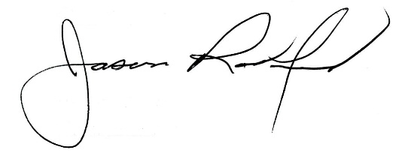


Carly Clem, Board Chairperson Superintendent Jason Radford

