Strategic Prevention Framework
I³: Inspired, Individualized, Inclusive
January 2024 - February 2025
Goal: To reduce the onset & progression of substance misuse & its related problems in Bellevue, KY, by supporting the development & delivery of community substance misuse prevention & mental health promotion services.
Objective 1: | By 9/29/2027, reduce the 30-day use of alcohol among tenth-grade students by 2% each year as measured by annual KIP survey data.
Objective 2: | By 9/29/2027, reduce regular (30-day) vaping use among tenth-grade students by 2% each year as measured by annual KIP survey data.
Objective 3: | By 9/29/2027, reduce regular (30-day) cigarette smoking among tenth-grade students by 2% each year as measured by annual KIP data.
Objective 4: | By 9/29/2027, tenth-grade students reporting serious psychological distress, according to the K6 KIP data, will decrease by 4% each year.
Objective 5: | By 9/29/2027, expand collaboration with community prevention partners, demonstrated by support from community prevention partners at least 2x each year in the project’s family prevention education opportunities, documented by photographic evidence & meeting notes.

ASSESSMENT
Accomplishments | Description | Align
Assessment of schools’ capacity: | I³ staff, in collaboration with GES & BMHS school leadership to complete the SEB Winter Screener | 1-5
Specification of baseline data: | SEB screeners will be given to all K-5 students (teacher-rated) and 6-12 (teacher-rated and youth-rated).  The data will be used within the MTSS framework to proactively detect students who need support beyond Tier 1 instruction & support. *  - GES completed teacher-rated on 12/18/24 (194 students)  - BMHS incomplete; scheduled to complete teacher-rated on 1/3/25  *Data utilized in MTSS meetings at GES, BMHS SEB data utilization unknown | 1-4
Monitoring schools needs assessment activities: | Internal Referrals for mental health services. *  2 internal referrals for services (GES only)  1 internal referral accepted  1 internal referral in progress  2 internal referrals for prevention services  2 internal referral assessment completed for prevention services  BMHS MTSS Tracker  GES MTSS Tracker  *Specific BMHS mental health referral data and internal referral assessments unknown | 1-4
Monitoring schools needs assessment activities: | External Referrals for mental health & prevention services. *  0 student/family external referral  0 student/family Care Solace referrals  0 staff member's Care Solace referrals  *Specific BMHS external referral data unknown | 1-4
Monitoring schools needs assessment activities: | Grant staff collect & monitor data on all grant lead initiatives. This includes, but is not limited to:  - Outreach & Engagement Data  - Participation Data  - Outcome Data  - Financial Data  - Progress Monitoring  SPF Data | 1-5
Use of needs assessment data: | Grant staff continues to redirect efforts to target the community with infrastructure development initiatives. | 5
CAPACITY
Accomplishments | Description | Align
Professional Development: | SPF Grant Staff:  - UK CTAC Trauma Informed Practices for Educators Learning Collaborative Learning  - Trauma Make and Take  - Navigators of the Commonwealth  - Operation Parent Substance Abuse and Athletes Webinar  GES Mental Health Professional:  - Trauma Informed Safety Planning  - The Body Keeps the Score Trauma Training (In progress) | 5
Building internal coalitions: | Grant staff participated in the following monthly coalition/committee meetings:  - GES PBIS Tier 2/3 Meeting  - GES Student Care Team Meeting  - GES Student Care Team - Ancillary Meeting  - BMHS Student Care Team Meeting  - Rae of Sunshine - SMILE Club Meetings | 5
Building external coalitions: | Grant staff participated in the following monthly coalition/committee meetings:  - North Key  - NKY ASAP  - SBMH Grant Committee Meeting  - TISS Grant Committee Meeting  - NKISP Steering Committee Meeting  - Campbell County Drug-Free Alliance General Meeting  - River Cities Drug-Free Coalition Meeting  - Madi’s House meeting | 5
Building external partnerships: | Grant staff meet with the following community agencies:  - North Key  - NKY Health Department  - Starbucks  - Kroger  - Trader Joe  - Perfetti Van Melle | 5
Community Conversations: | - North Key – TGFD Curriculum  - CCDFA to discuss video campaign & Prom initiative  - City of Bellevue for Winter Carnival
Other infrastructure development: | - Review & update the webpage with resources weekly  - MH&Prevention Webpage  - Resource mapping review & update support for students, staff, & families  - BISD Resource Map | 5
PLANNING
Accomplishments | Description | Align
Articulation of a vision for prevention activities: | Grant staff will work with school leadership to discuss the following:  - Implementation of video campaign  - Implementation of Too Good for Drugs  - Implementation of GES Health Classes  - Prevention Scope of Practice & Caseload  - Pop the Stigma event  - MTSS tiered level of support & SEB Screener Capacity & Decision Rules | 1-5
Articulation of a vision for prevention activities: | Grant staff are working toward planning the following:  District  - Lockbox Video Campaign with CCDFA and SMILE Club  - Pop the Stigma  - #SEL Day  GES  - Too Good for Drugs Curriculum with NKY Health Department & North Key  BMHS  - SMILE Club  FEBRUARY  - 02/17 – Random Acts of Kindness Day  - 02/18 – Dinner Table Project #3  - 02/19 – SMILE Club Concession Stand Fundraisers  - 02/19 – Safety Net Alliance Meeting  - 02/21 – Spill the Tea Initiative  - 02/21 – NKU Resource Fair  - 02/22 – City of Bellevue Winter Carnival  - 02/26 – Navigators of the Commonwealth  - 02/27 – Madi’s House Lunch & Learn  - 02/27 – Filming CCDFA Video Campaign  MARCH  - 03/02 – Teen Mental Health Awareness Day  - 03/03 – #SEL Day  - 03/11 – GES Open House  - 03/18 – SPF Advisory Board Meeting  - 03/21 – Spill the Tea  - 03/21 – Newsletter #4  - 03/24 – NKCES Make & Take Event  APRIL  - Alcohol Awareness Month  - 04/01 – Take Down Tobacco Day  - 04/02 – KY Tobacco Control Conference  - 04/04 – Prom initiative with CCDFA  - 04/09 – Cannabis and Other Drugs Prevention Conference (Virtual)  - 04/15 – Dinner Table Project #4  - 04/18 – Spill the Tea  - 04/30 – Navigators of the Commonwealth  SPRING  - Classroom Lockbox initiative/video campaign  - NKY Student Mental Health Roundtables  - Newsletters  - Field Day  - Weekly Rae of Sunshine – SMILE Club Meetings  - Mental Health Month  - Mental Health Day of Action | 1-4
Identification of the district-level priorities: | Mental Health & Prevention Services Handbook — I³ team continues to create an evidence-based policy and procedural handbook for BISD’s mental health and prevention services.  - Outlines the screening process  - Details referral process  - Includes information about MTSS | 1-5
Identification/coordination/allocation of resources: | Trauma-Informed Grant – The I³ team is working with NKCES to evaluate the strengths and weaknesses of BISD’s Trauma Plan. The team will review recommendations based on the trauma-informed walkthrough that took place on 12/4. | 4
IMPLEMENTATION
Accomplishments | Description | Align
Specific community-level interventions being implemented: | Grant staff implemented the following:  JANUARY  - 01/17 – Spill the Tea  - 01/17 – I3 Newsletter #3  - 01/21 – I3 Advisory Meeting  - 01/22 – Self-esteem Groups @ GES  - 01/22 – 5K Planning  - 01/24 – National Compliment Day  - 01/28 – NKCES Trauma Make & Take  - 01/29 – SMILE Club Concession Stand Fundraisers  - 01/29 – Vanessa Kuhn recognized as Super Care Hero  - 01/30 – Video Campaign Kickoff  FEBRUARY  - 02/03 – SMILE Club Concession Stand Fundraisers  - 02/07 – Pop the Stigma Initiative partnered with Perfetti Van Melle  - 02/10 – SMILE Club Concession Stand Fundraisers  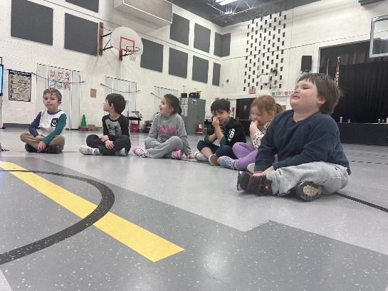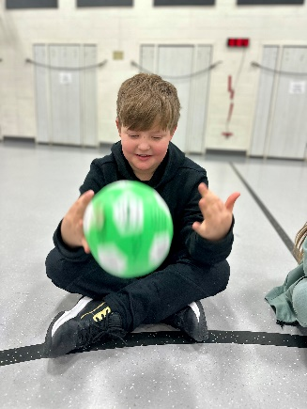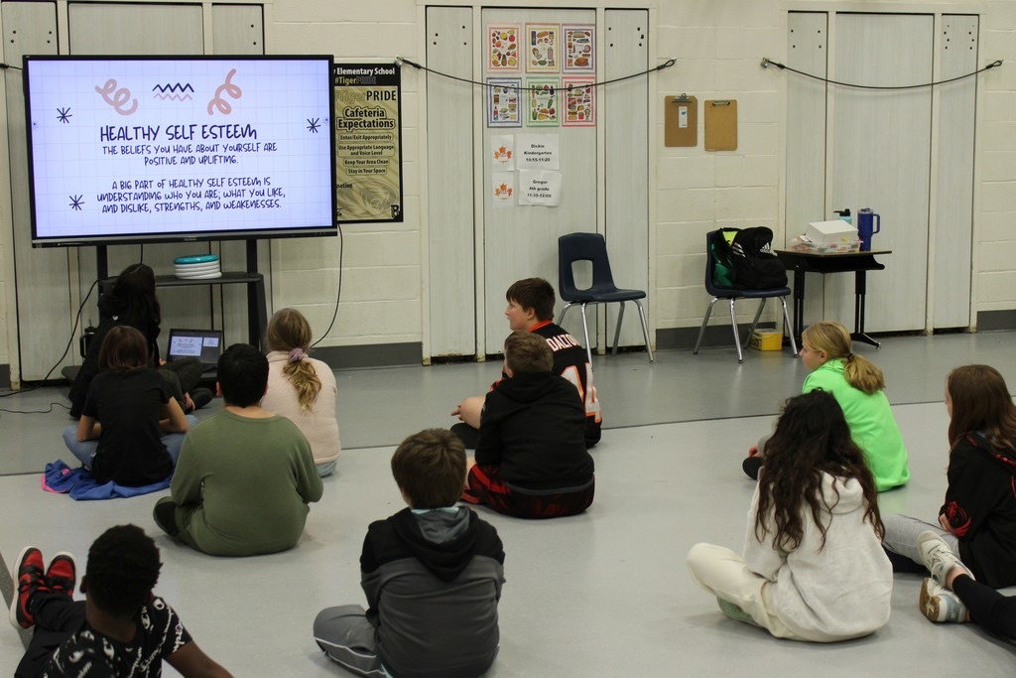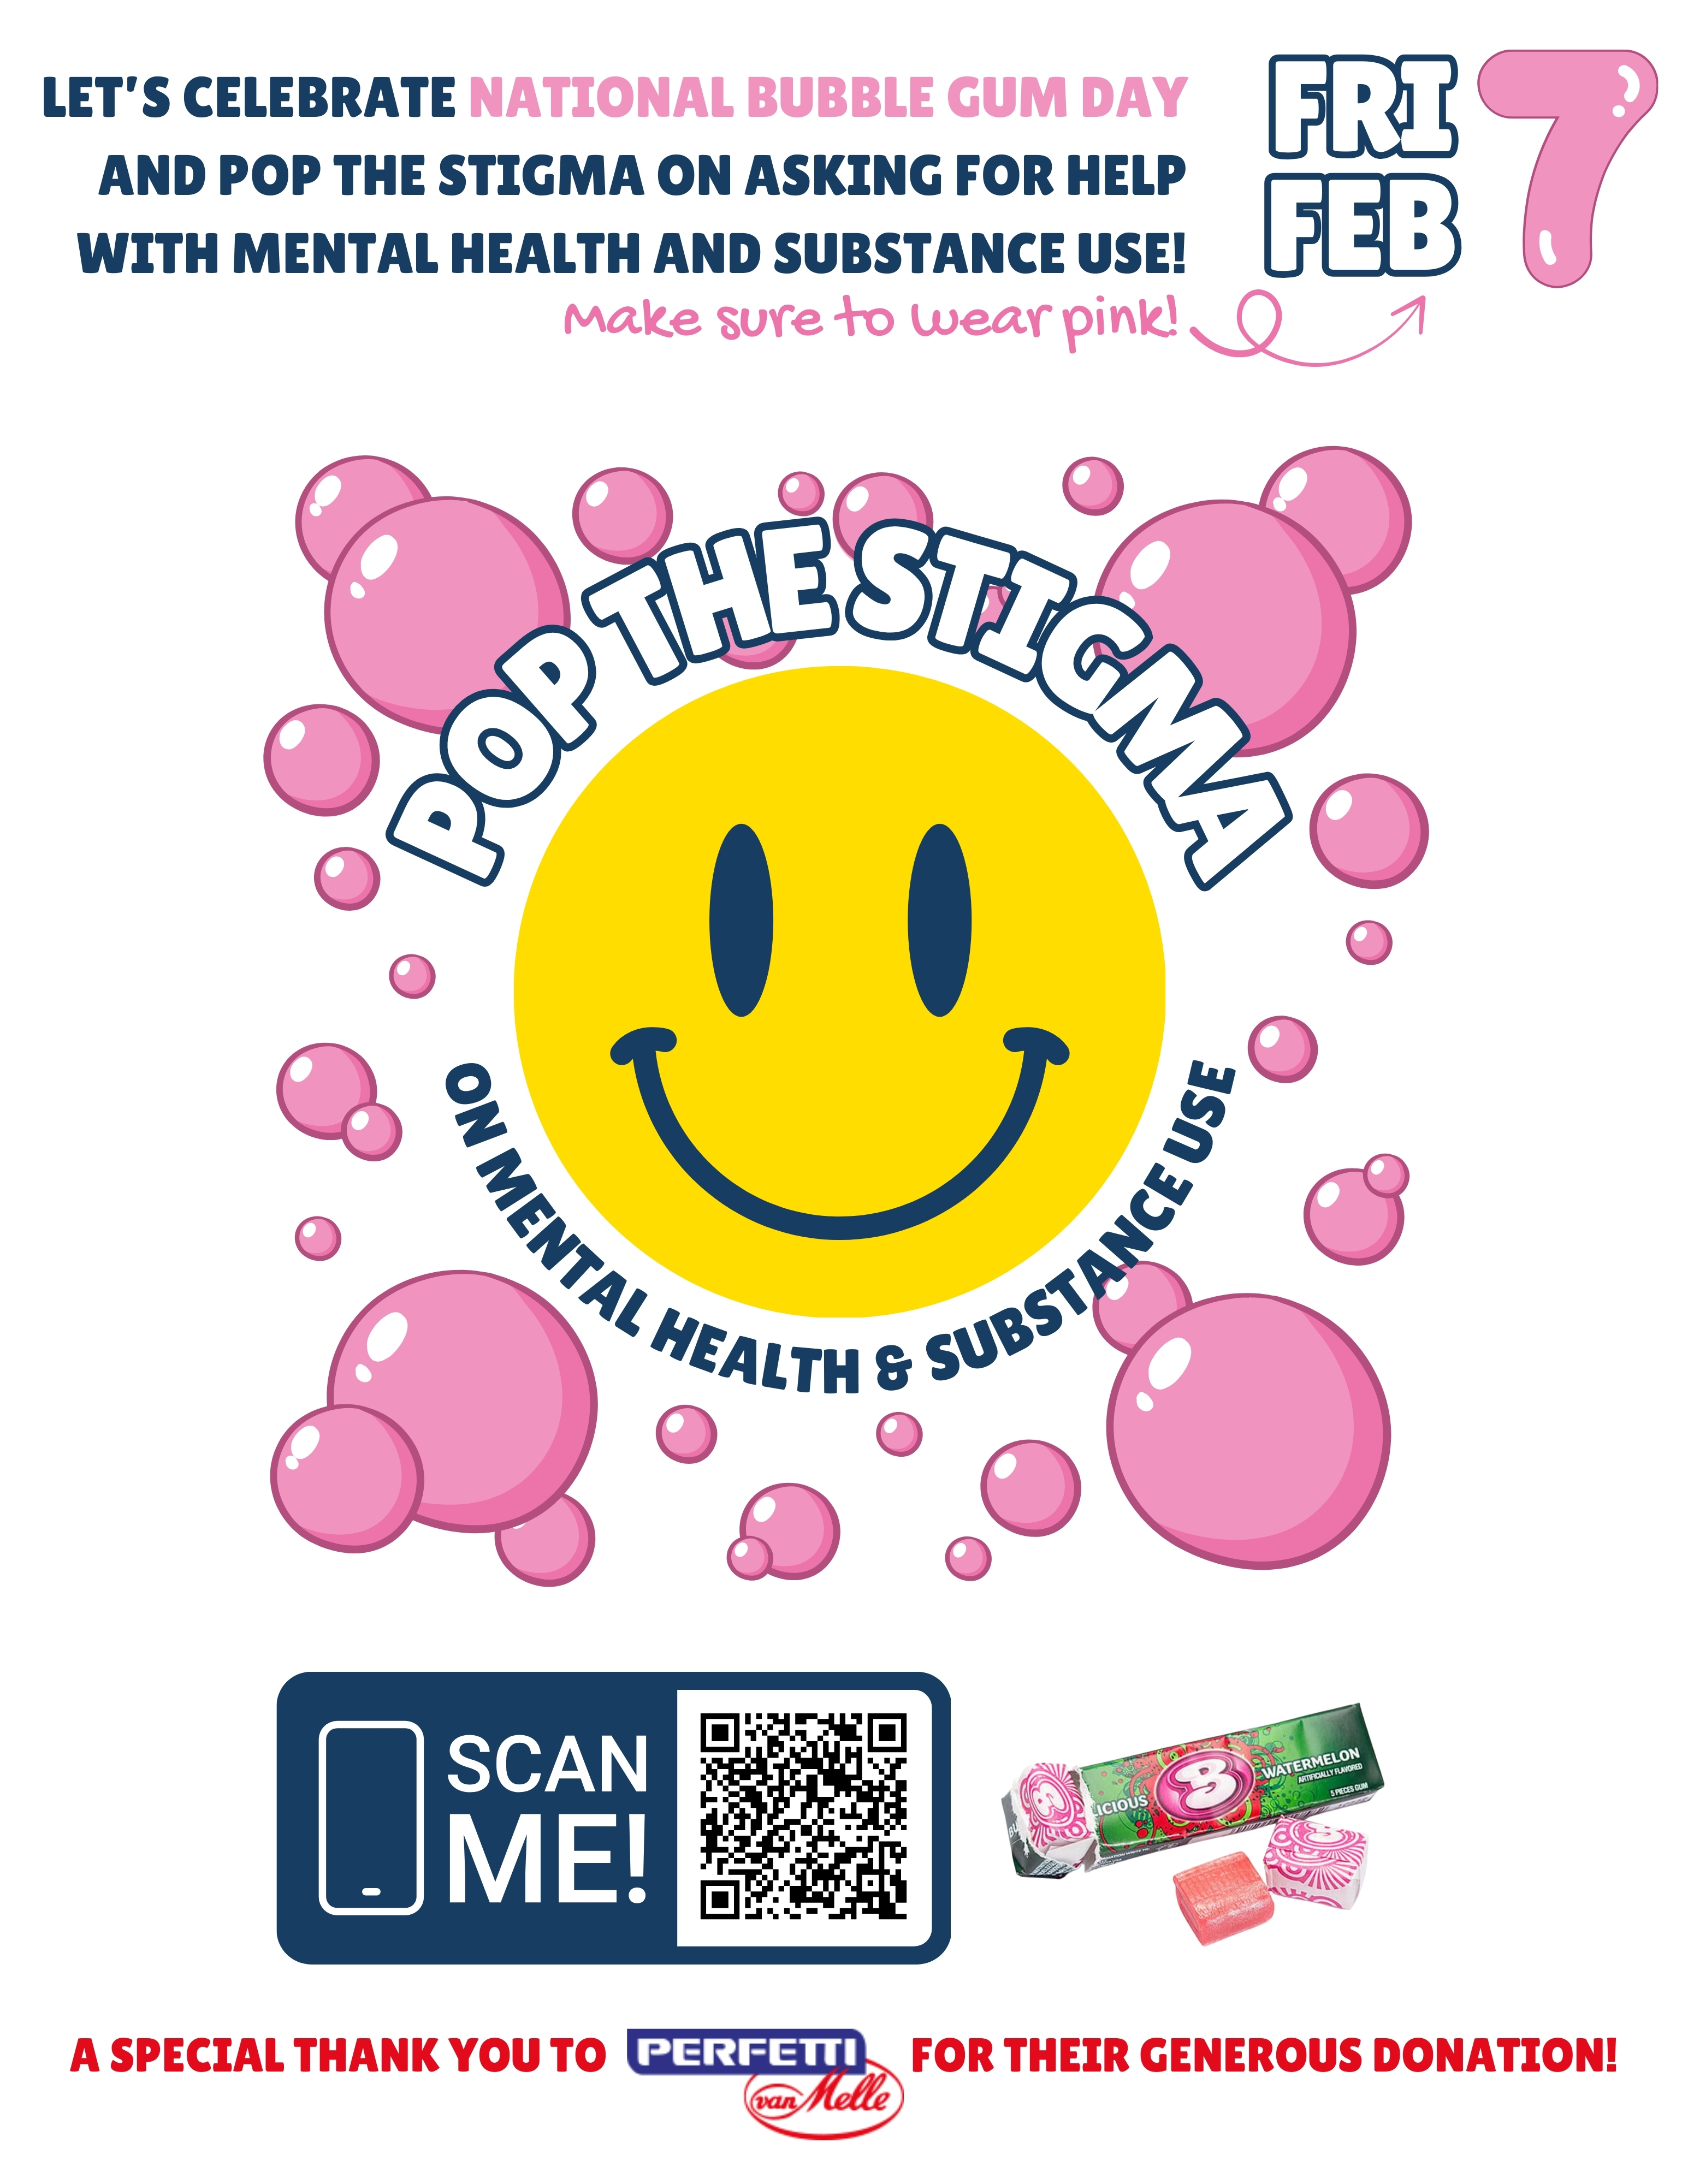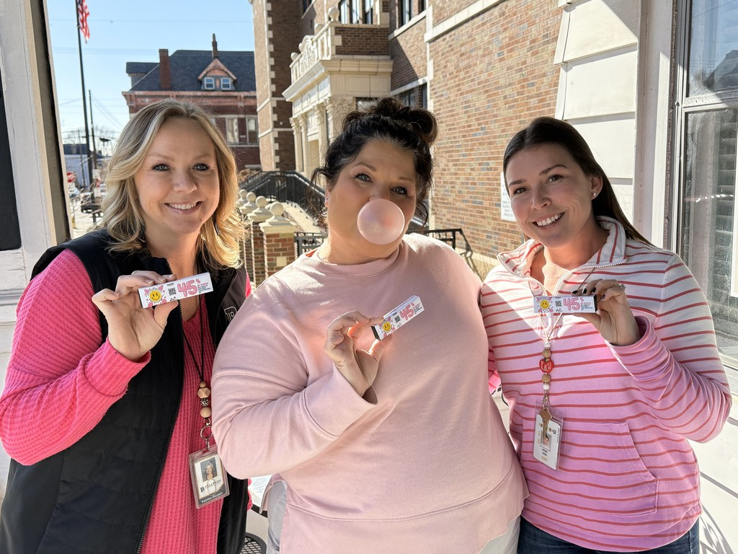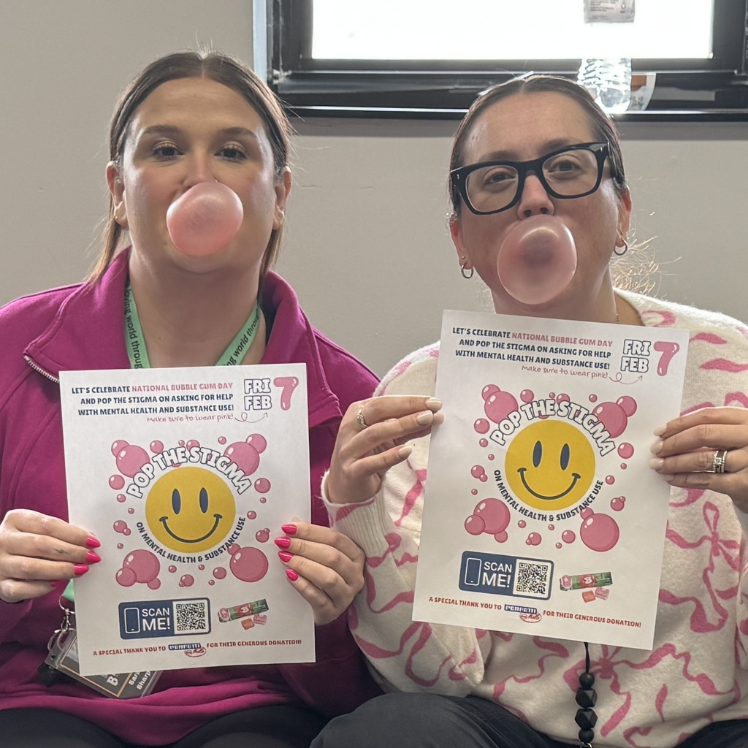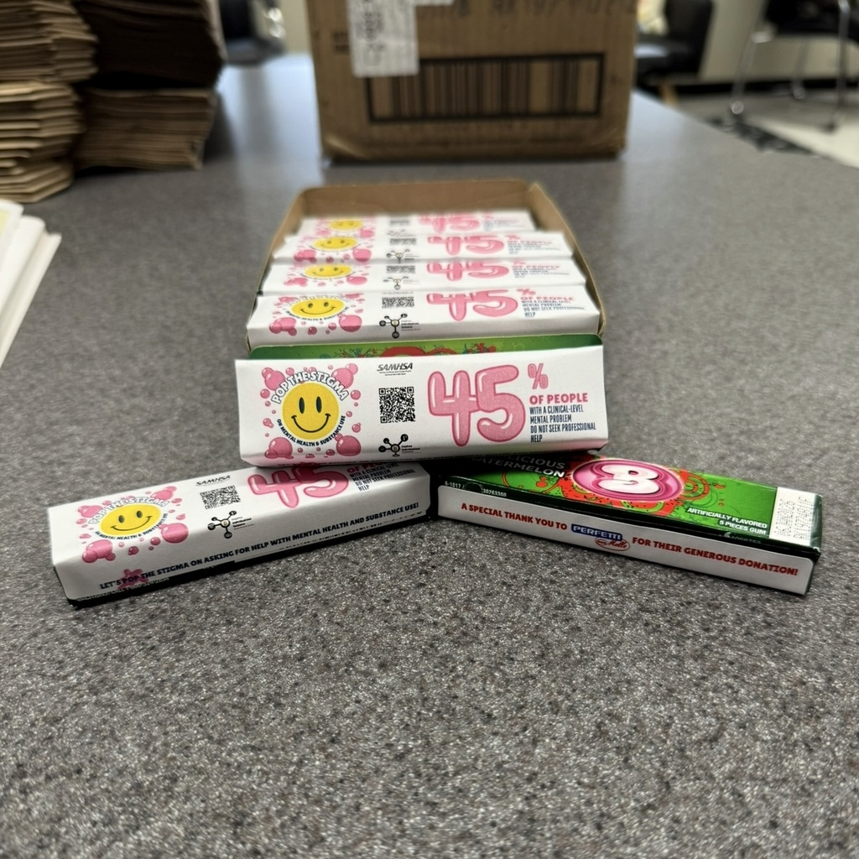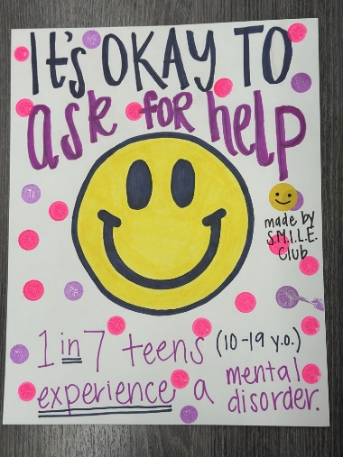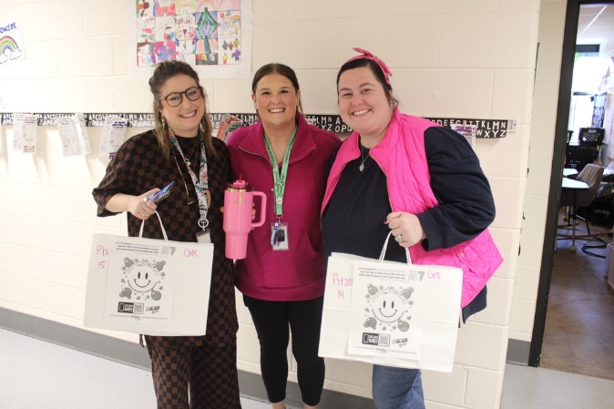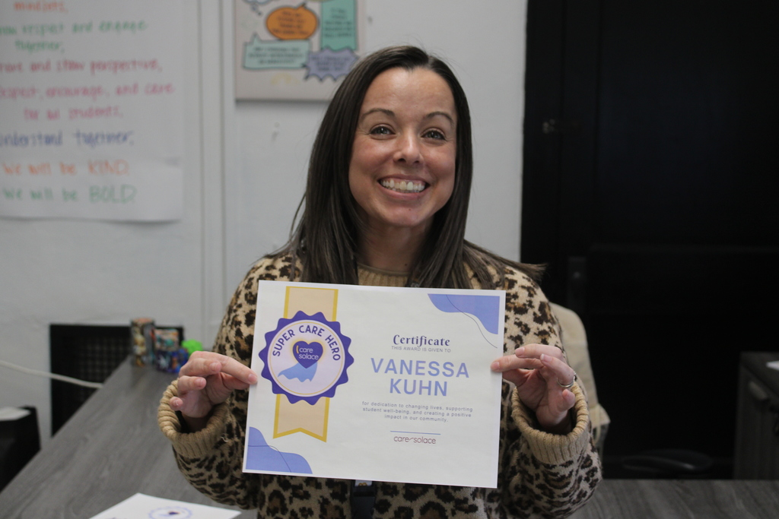
Implemented policies within organizations to facilitate interventions | Grant staff works with the following grants to create procedures for the BISD mental health & prevention team in response to students' & families' mental health & prevention needs. These align with best practices.  - Trauma-Informed Grant  - Grant staff continues to work with TISS Grant to revise BISD’s trauma-informed plan & create action steps to ensure the implementation of best practices.  - Grant staff continues to work with SBMH Grant to review & revise BISD’s Mental Health plan & create action steps to ensure the implementation of best practices.  - School-Based Mental Health Grant  - Grant staff continues to work with SBMH Grant to review & revise BISD’s Mental Health plan & create action steps to ensure the implementation of best practices.  - Prevention  - Grant staff continues to review & revise BISD’s Prevention plan, creating action steps to ensure the implementation of best practices.  - Created district tobacco/nicotine-free procedure in response to HB-142; the procedure was added to the Code of Conduct and middle/high school behavior matrix. | 4
Specific community-level interventions being implemented: | SBMH Breakdown of time and/or student reached/seen:  - Direct: 2,120 minutes = 35.3 hours  - Total Sessions: 53  - Extra Sessions: 10, 275 minutes = 4.6 hours  - Indirect: 1,280 minutes = 21.3 hours  SBMH GES Caseload Numbers:  - Active cases: 17  - Tier 2 performance: 0  - Referrals: 2 | 4
Specific community-level interventions being implemented: | Prevention Breakdown of time and/or student reached/seen:  - Total sessions: 18  - Total direct sessions: 15  - Total extra sessions: 3  - Groups: 0  - Tier 2 performance: 0  Prevention Caseload Numbers:  - Active cases: 6  - Referrals: 2  - Pending: 2  - Tier 2 performance: 0 | 1-4
Developed systems for distributing resources: | 0 lockboxes distributed to families  - 22 distributed in total  0 deterra bags distributed to families  - 0 distributed in total  - 75 available | 1-3
EVALUATION
Accomplishments | Description | Align
Monitor & evaluate all activities: | Evaluating SEB data to support our developing MTSS. | 4
Monitor & evaluate all activities: | SPF Grant Data  - Outcome data collected on the number of event impressions and post-survey information  - Data submitted to SPARS  Total Served to Date = 3,355  Total Interactions to Date = 9,464  Total Reached to Date = 52,835  GES Health Class for Self-esteem = 159 served, 907 interactions, 3273 reached  Newsletter #3 = 24 served, 588 interactions, 1062 reached  Lockboxes = 22 served  SMILE Club Positive Posters = 30 posters, 1041 interactions, 5163 reached  Pop the Stigma = 507 served  Total to Date:  Dinner Table Project = 586 served, 1696 interactions, 6366 reached  Spill the Tea = 29 served, 982 interactions, 6517 reached | 4
Monitor & evaluate all activities: | GES Self-esteem pre- and post-survey collected (63 students) and reviewed for continuous improvement. | 4
Monitor & evaluate all activities: | #iCANendthetrend post-survey #1 collected; will review once results are received from the program.  - Waiting to complete post-survey #2 when received | 1-5
Grant Reporting: | - 12/31 – SPF eRa Commons Annual Performance Review – Submitted  - 12/31 – SPF eRa Commons Carryover – Submitted  - 01/31 – SPF Continuation Report – Submitted  - 03/30 – SPF SPARS Quarter 1 & 2 Report – Due

SUSTAINABILITY
Planning for sustaining the infrastructure: | Continue developing & improving the district's MTSS system & mental health support. SEL teams deliver substance abuse prevention curriculum to students.

