ACTION ITEM C
February 4, 2025
OLDHAM COUNTY BOARD OF EDUCATION
CONCERN
Consider approval of resolution authorizing the issuance of approximately $62,575,000 of General Obligation Bonds by the Oldham County School District to fund site and accessibility improvements at various elementary schools, stadium upgrades and improvements, and renovations and improvements and improvements at Oldham Co High School and Buckner High School.
DISCUSSION
Kelly Mrsic with Baird Financial will be at the meeting to request approval of the following resolution:
A RESOLUTION OF THE BOARD OF EDUCATION OF THE OLDHAM COUNTY SCHOOL DISTRICT AUTHORIZING THE ISSUANCE OF ITS GENERAL OBLIGATION BONDS, SERIES 2025A, IN AN ESTIMATED AGGREGATE PRINCIPAL AMOUNT OF $62,575,000 (SUBJECT TO A PERMITTED ADJUSTMENT INCREASING THE PRINCIPAL AMOUNT OF BONDS BY UP TO $6,257,000 OR DECREASING THE PRINCIPAL AMOUNT OF BONDS BY ANY AMOUNT), IN ACCORDANCE WITH SECTIONS 66.011 THROUGH 66.191 AND SECTION 160.160 OF THE KENTUCKY REVISED STATUTES, FOR THE PURPOSE OF FINANCING THE ACQUISITION, CONSTRUCTION, RENOVATION, EQUIPPING, AND INSTALLATION OF Site and accessibility improvements at various elementary schools throughout the District, stadium upgrades and improvements at various high schools throughout the District, and improvements and renovations at Oldham County High School and Buckner High School; APPROVING THE FORM OF THE BONDS; AUTHORIZING DESIGNATED OFFICERS TO EXECUTE AND DELIVER THE BONDS; PROVIDING FOR THE PAYMENT AND SECURITY OF THE BONDS; ESTABLISHING A BOND PAYMENT FUND FOR THE BONDS; ESTABLISHING A SINKING FUND; AUTHORIZING THE ACCEPTANCE OF THE BID OF THE PURCHASER FOR THE BONDS; AND AUTHORIZING AND APPROVING THE EXECUTION OF ANY FURTHER NECESSARY INSTRUMENTS.
RECOMMENDATION
Approve the resolution authorizing the issuance of approximately $62,575,000 of General Obligation Bonds by the Oldham County School District to fund site and accessibility improvements at various elementary schools, stadium upgrades and improvements, and renovations and improvements at Oldham Co High School and Buckner High School.

On a motion by _______________, seconded by _______________, the Board approved the resolution authorizing the issuance of approximately $62,575,000 of General Obligation Bonds by the Oldham County School District to fund site and accessibility improvements at various elementary schools, stadium upgrades and improvements, and renovations and improvements at Oldham Co High School and Buckner High School ( , ).
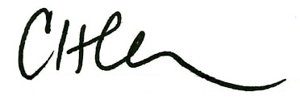
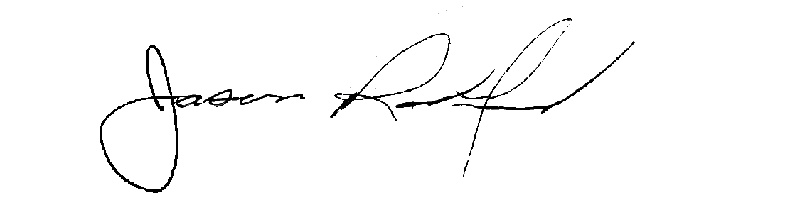

Carly Clem, Board Chairman Jason Radford, Superintendent / Secretary

