EXECUTIVE SESSION
February 4, 2025
OLDHAM COUNTY BOARD OF EDUCATION
CONCERN
Consider Executive Session pursuant to KRS 61.810(1)(b) deliberations on the future acquisition or sale of real property by a public agency, but only when publicity would be likely to affect the value of a specific piece of property to be acquired for public use or sold by a public agency.
DISCUSSION
At this time, I need a motion to go into Executive Session pursuant to KRS 61.810(1)(b) deliberations on the future acquisition or sale of real property by a public agency, but only when publicity would be likely to affect the value of a specific piece of property to be acquired for public use or sold by a public agency.
RECOMMENDATION
Conduct Executive Session.

On a motion by _______________, seconded by _______________, the Board entered into Executive Session pursuant to KRS 61.810(1)(b) deliberations on the future acquisition or sale of real property by a public agency, but only when publicity would be likely to affect the value of a specific piece of property to be acquired for public use or sold by a public agency.( - )

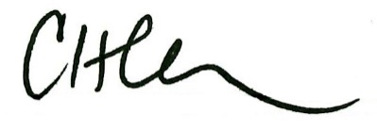
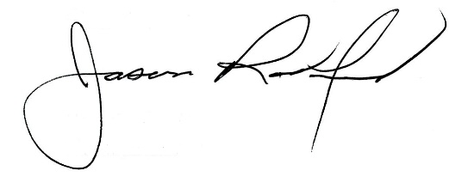

Carly Clem, Board Chair Jason Radford, Superintendent/Secretary

