ACTION ITEM B
January 30, 2025
OLDHAM COUNTY BOARD OF EDUCATION
CONCERN
Consider approval of using KSBA Services for the 2025 Superintendent Search.
DISCUSSION
After meeting with Don Martin of KSBA to review services offered, the board will determine if they agree to use KSBA to facilitate in the 2025 Superintendent Search.
RECOMMENDATION
Approve the hiring of KSBA Superintendent Search Services.

On a motion by _______________, seconded by _______________, the Board approved hiring of KSBA Superintendent Search Services. ( , )

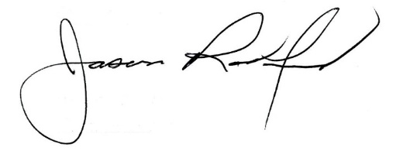
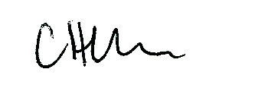

Carly Clem, Board Chair Jason Radford, Superintendent/Secretary

