ACTION ITEM A
January 30, 2025
OLDHAM COUNTY BOARD OF EDUCATION
CONCERN
Review Receipts and Expenditures (Draft Budget) for the year ending June 30, 2026 (FY26)
DISCUSSION
The Kentucky Department of Education requires each Local Board of Education to review receipts and expenditures toward preparation of a Draft Budget (excluding multi-year funds, i.e. grant funds and construction funds) for the next fiscal year no later than January 31 of the current fiscal year.
The Draft Budget is prepared mainly for compliance purposes and provides budget information based on current year operations and FY25 projected expenditures. As such, the Draft Budget should be viewed as a basis for beginning discussions related to the preparation of Tentative and Working Budgets for FY26.
See attached revenue projections from the discussion at the Board Work Session on December 02, 2024
RECOMMENDATION
Review the attached projections in preparation for discussions related to the completion of the FY26 Draft Budget, and direct the Superintendent to continue to revise budget estimates as additional information becomes available.

On a motion by _______________, seconded by _______________, the Board approved the FY26 Draft Budget, and direct the Superintendent to continue to revise budget estimates as additional information becomes available. ( - )

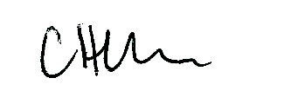
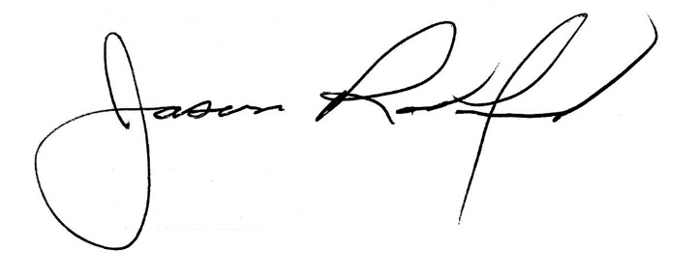

Carly Clem, Board Chair Jason Radford, Superintendent/Secretary

