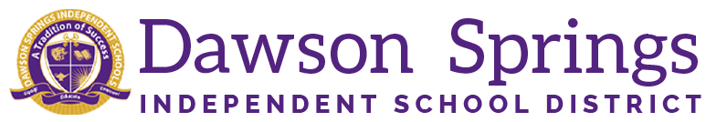

Dawson Springs Elementary School
Where the teachers and students give 100% every day and failure is not an option.
Panthers Prowling to Proficiency!

January 2025 Board Meeting
Elementary Principal Report
Jennifer Ward

- Academic Progress
  - Winter iReady Diagnostics are complete.
  - Growth in every grade level in reading and math for the percentage of students who are at or above grade level.
  - Reading
    - 58% of students in kindergarten are at or above grade level
    - 46% of Third graders are at or above grade level
  - Math
    - 34% of students in kindergarten are at or above grade level
    - 41% of fifth graders are at or above grade level
- PLC Conversations for the Month:
  - Our book study on Focus Elevating the Essentials to Radically Improve Student Learning BY Mike Schmoker continues. Lots of great conversations and implementation into the classrooms.
  - 3rd - 5th graders participated in the Mock KSA assessment .
    - Teachers are now having conferences with students to go over formatting of the assessment so it is not an obstacle when the end-of-year testing occurs.
  - Tier 3 RTI ESS data is being entered into IC for monitoring purposes.
    - This information is tailored to the bottom 5% of our students in both reading and math.
  - Reading Intervention Plans are also being monitored in our classrooms. This is for students who scored below the 25% ile on our fall iReady diagnostic exam. These students are monitored above the Tier 3 RTI students to ensure they move forward and not fall further behind in the area of reading. Instruction is given to these students using our iReady literacy tasks and they are benchmark tested to monitor progress.

- Upcoming Events:
  - We are going to schedule our spring parent teacher conferences for this semester.
  - We are looking at some more family engagement activities we can do this year as well.

