Reading
2024/2025 Fall to Winter growth by Grade Level
Percentage of students at or above grade level

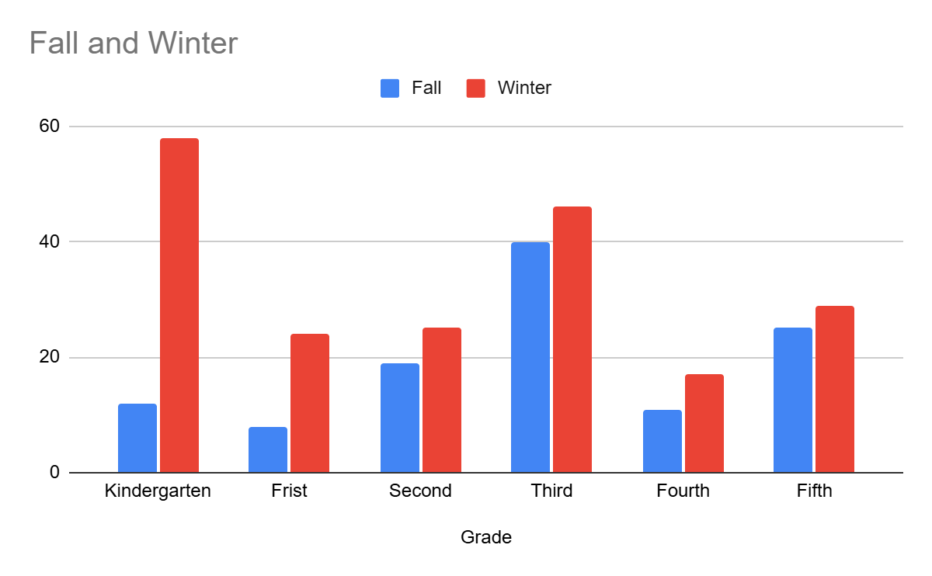

Reading | Column 1 | Column 2
Grade | Fall | Winter
Kindergarten | 12 | 58
Frist | 8 | 24
Second | 19 | 25
Third | 40 | 46
Fourth | 11 | 17
Fifth | 25 | 29

Math
2024/2025 Fall to Winter growth by Grade Level
Percentage of students at or above grade level

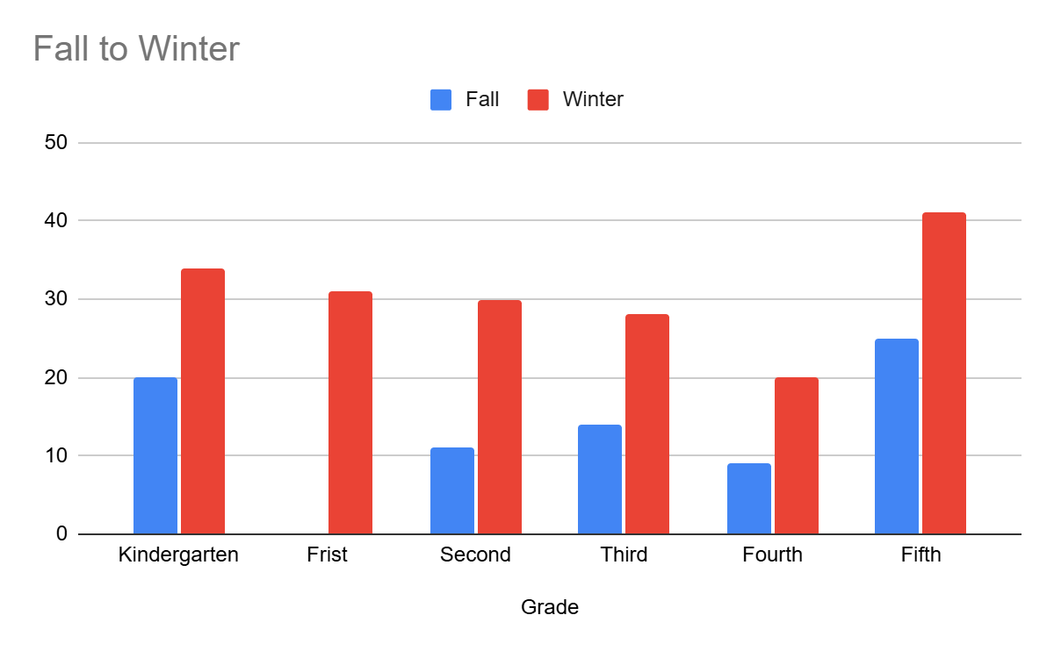

Grade | Fall | Winter
Kindergarten | 20 | 34
Frist | 0 | 31
Second | 11 | 30
Third | 14 | 28
Fourth | 9 | 20
Fifth | 25 | 41

