CONSENT ITEM D
January 27, 3025
OLDHAM COUNTY BOARD OF EDUCATION
CONCERN
Consider Approval of Contracts in excess of $40,000 and donations in excess of $1000.
DISCUSSION
Pursuant to Board Policy 04.32, the Superintendent can approve contracts for transactions of less than $40,000 in value. Below are listed the name of the contract vendor, the subject of the contract, and the amount of the contract in excess of $40,000 that must be approved by the Board. Donations over $1000 must be approved by the board.
School/Dept |  | Vendor | Subject | Amount
MOA |  | Georgetown University | Student Teacher placement | -
MOA |  | Georgia State University | Teacher Training agreement | -
MOA |  | UK | Clinical Practice Agreement | -
DONATIONS
OCHS | Athletic Boosters |  | Football | $1,000.00
OCHS | Mockingbird Management |  | Soccer | $1,350.00
OCHS | Athletic Boosters |  | Baseball | $3,000.00
KSE | PTO |  | Tiger Trek | $10,000.00
Goshen | PTO |  | Techers | $13,250.00
SOHS | Thompson |  | Marine Biology Trip Donation | $1,000.00
KSE | Art to Remember |  | Art | $2061.59
SOHS | Athletic Boosters |  | Various | $14,000.00
RECOMMENDATION
Approved the attached contracts and donations and authorized the Superintendent and Secretary of the Board, or his designee, to execute all the above contracts, and ratified any contracts of these contract signed prior to formal approval.

On a motion by _______________, seconded by _______________, the Board approved the attached contracts and authorized the Superintendent and Secretary of the Board, or his designee, to execute all of the above contracts for formal approval. (5,0)

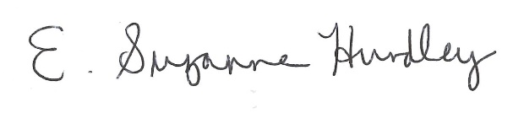
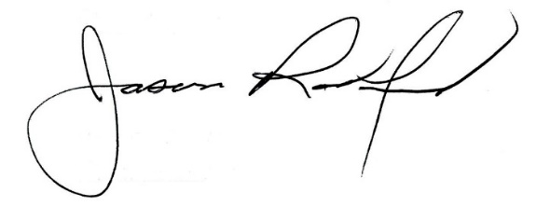

Suzanne Hundley, Board Chair Jason Radford, Ed.D, Superintendent

