MINUTES
January 27, 2025
OLDHAM COUNTY BOARD OF EDUCATION
CONCERN
Consider Approval of Meeting Minutes.
DISCUSSION
The draft minutes of the December 16, 2024, Regular Board Meeting, January 13, 2025, Special Called Work Session, January 16, 2025, Special Called SBDM, January 22, 2025, Special Called Expulsion Hearing are available for review and approval.
RECOMMENDATION
Approve the minutes of the following meetings as presented.
December 16, 2024 – Regular Board Meeting
(1) Suzanne Hundley, Chairperson, (2) Larry Dodson, Board Vice Chair; (3) Joe Dennis, Board Member (4) Carly Clem, Board Member and Dr. Jason Radford, Superintendent and Secretary to the Board were present.
January 13, 2025 – Special Called Work Session Meeting
(1) Suzanne Hundley, Chairperson, (2) Joe Dennis, Board Member, (3) Carly Clem, Board Member (4) Allison Sheffer, Board Member, (5) Adam Springer, Board Member were present.
January 16, 2025 – Special Called SBDM Meeting
(1) Suzanne Hundley, Chairperson, (2) Joe Dennis, Board Member, (3) Carly Clem, Board Member (4) Allison Sheffer, Board Member, (5) Adam Springer, Board Member, and Dr. Jason Radford, Superintendent and Secretary to the Board were present.

On a motion by _______________, seconded by _______________, the Board approved the minutes of the December 16, 2024, Regular Board Meeting. (5,0)
On a motion by _______________, seconded by _______________, the Board approved the minutes of the January 13, 2025-Special Called Work Session. ( , )
On a motion by _______________, seconded by _______________, the Board approved the minutes of the January 16, 2025-Special Called SBDM. ( , )
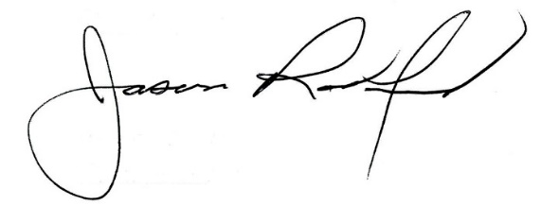
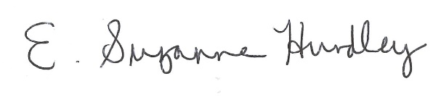

___________________________________ ______________________________
Suzanne Hundley, Board Chair Jason Radford, Superintendent/Secretary

