OLDHAM COUNTY BOARD OF EDUCATION
January 16, 2025, 4:45PM
ARVIN EDUCATION CENTER
1650 Colonels Drive, La Grange, KY 40031
Attendance Taken at: 4:41 PM
Present Board Members:
Mrs. Suzanne Hundley
Mr. Adam Springer
Ms. Carley Clem
Ms. Allison Sheffer
- MEETING CALLED TO ORDER
Chairperson Hundley called the meeting to order at 4:41 p.m.
- AGENDA APPROVAL
Chairperson Hundley called for motions to approve the agenda; motioned by Carly Clem, seconded by Allison Sheffer, the Board approved the January 16, 2025, special-called meeting agenda. (4-0).
- ACTION ITEMS
- On a motion by Allison Sheffer, seconded by Carly Clem, the Board approved the declaration for the Oldham County Board of Education Superintendent Search. (4 ,0)
- On a motion by Adam Springer, seconded by Carly Clem, the Board Approve the reallocation of salary for the Deputy Superintendent position for the 2024-2025 school year as outlined above for the 2004-2025 school year only. (4,0)
- SBDM COUNCIL REPORTS
- The Board conducted annual discussions with the SBDM Council from NOMS.
Allison Sheffer left the meeting @ 5:18pm.
- The Board conducted annual discussions with the SBDM Council from OCMS.
The board took the reports under advisement, no action was taken.
BREAK
The Board took a short dinner recess at 5:45 p.m. and resumed their meeting at 6:15 p.m.
SBDM COUNCIL REPORTS
- The Board conducted annual discussions with the SBDM Council from EOMS.
Allison Sheffer returned to the meeting @ 6:36pm.
- The Board conducted annual discussions with the SBDM Council from SOMS.
- The Board conducted annual discussions with the SBDM Council from OC Arts Center/CAPAA.
The board took the reports under advisement, no action was taken.
- ADJOURN
With no further business to discuss and acting on the Superintendent's recommendation to adjourn, Chairperson Hundley called for motions. On a motion by Carly Clem, seconded by Allison Sheffer, and unanimously carried, the Board adjourned the January 16, 2025, SBDM meeting at 7:55p.m. (4-0).
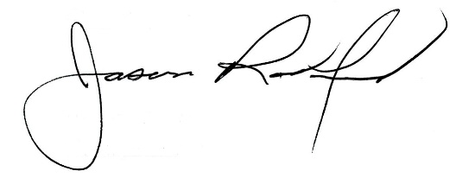
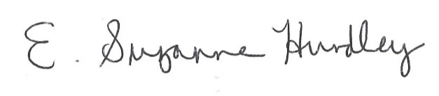

Suzanne Hundley, Board Chairperson Superintendent Jason Radford

