Approved by the Oldham County
Board of Education
June 24, 2024

OLDHAM COUNTY BOARD OF EDUCATION
SPECIAL CALLED MEETING
January 13, 2025
Oldham County District Office
6165 W HWY 146, Crestwood, KY 40014
Attendance Taken at: 4:45 PM
Present Board Members:
Mrs. Suzanne Hundley
Mr. Joe Dennis
Ms. Carly Clem
Ms. Allison Sheffer
Mr. Adam Springer
- CALL MEETING TO ORDER
Chairperson Hundley called the meeting to order at 4:45 pm.
- APPROVE AGENDA
Motion Passed: Approval of the Agenda passed with a motion by Carly Clem, seconded by Joe Dennis. 5 Yeas - 0 Nays.
- SUPERINTENDENT REPORTS
- Brent Deaves, Interim Deputy Superintendent led discussion on budget considerations and recommendations for FY26. The report was taken under advisement, no action was taken by the board.
- Rudi Ellis, Board Attorney led a discussion on Superintendent Search procedures. The report was taken under advisement, no action was taken by the board.
- ADJOURN
With no further business to discuss, Chairperson Hundley called for a motion and second to adjourn. On motion by Carly Clem, seconded by Joe Dennis, the Board adjourned the January 13, 2025, special called meeting at 6:57 p.m. 5 Yeas - 0 Nays

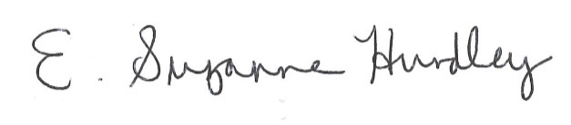
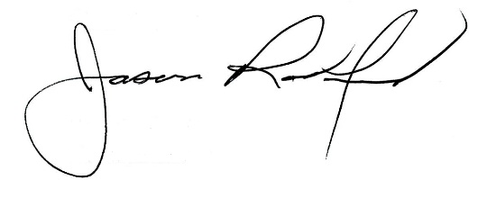

Suzanne Hundley, Board Chair Jason Radford, Superintendent/Secretary

