CONSENT ITEM A
January 27, 2025
OLDHAM COUNTY BOARD OF EDUCATION
CONCERN
Consider Approval of Field Trips Requesting Overnight Stay & Field Trips Requesting Use of Common Carrier.
DISCUSSION
The following are field trips requesting overnight stay and trips requesting use of a common carrier:
SCHOOL | GROUP | LOCATION/DATE | JUSTIFICATION | INSTR. DAYS LOST
EOMS | KUNA | Crowne Plaza  March 16-18, 2025 | Overnight: KUNA Conference  Parents | 2
SOMS | KUNA | Crowne Plaza  March 6-8, 2025 | Overnight: KUNA  Parents | 2
NOHS | KUNA | Crowne Plaza  March 2-4, 2025 | Overnight: KUNA  Parents | 2
SOHS | Band | Galt House  February 5-8. 2025 | Overnight: All State Band  Parents | 2
SOHS | Winterguard | Indianapolis, IN  February 22-23, 2025 | Overnight: Competition  Parents | 0
SOHS | Winterguard | Dayton, OH  April 3-5, 2025 | Overnight: Competition  Parents | 0
SOMS | KUNA | Crowne Plaza  March 6-8, 2025 | Overnight: KUNA  Parents | 2
ARVIN | HOSA | Crowne Plaza  March 20-22, 2025 | Overnight: HOSA Conference  Parents | 2
Approve the field trips as attached and described above, pursuant to the condition that students not traveling on school buses, with their parents, or with a Board employee whose insurance carrier has named OCBE as an additional named insured, will be transported to and from their destination on an approved charter bus(es) and school(s) shall obtain written evidence of liability.

Motion Passed: Motion by _______________, seconded by _______________, the Board gave approval of the field trips as attached and described above, pursuant to the condition that students not traveling on school buses, with their parents, or with a Board employee whose insurance carrier has named OCBE as an additional named insured, will be transported to and from their destination on an approved charter bus(es) and school(s) shall obtain written evidence of liability. ( , )

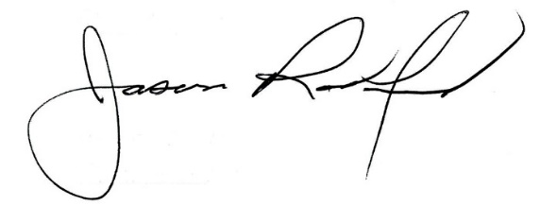
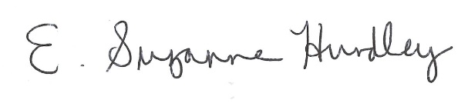

Suzanne Hundley, Board Chair Jason Radford, Superintendent/Secretary

